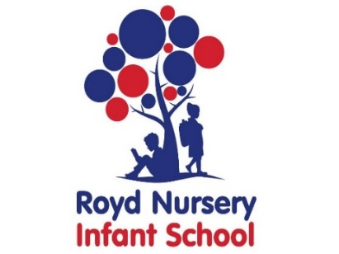

Royd Nursery Infant School

Carr Road, Deepcar

Sheffield, S36 2PR

Tel 0114 288 2594

Email [enquiries@royd.sheffield.sch.uk](mailto:enquiries@royd.sheffield.sch.uk)

[www.roydnurseryinfants.co.uk](http://www.roydnurseryinfants.co.uk)

Headteacher: Louise Jones

15 April 2025

Dear Parent / Carer

Each year, Royd Reception children take part in the exciting activity of Forest Schools and they have been a huge success.

**What is Forest Schools?**

Forest Schools is a fun, exciting way to learn in an outdoor setting such as woodlands. It is proven to improve children’s confidence, self-esteem, and communication skills as well as having lots of fun! They also develop skills in teamwork, using tools safely and learning about looking after our woodlands.

Over four sessions, the children will take part in a range of activities including exploring the woodlands, den-building, playing games.

**What will my child need?**

Forest Schools will happen in **all weathers** (unless it is VERY windy), so please make sure your child is dressed appropriately for the weather e.g. a jumper, a sun hat, **boots or wellies** and a waterproof coat. Please ensure your child wears trousers or if they are wearing a dress, please ensure tights are worn.

**When will Forest Schools happen?**

Tuesday 6 May 1.40 pm – 3.10 pm

Friday 9 May 1.40 pm – 3.10 pm

Tuesday 13 May 1.40 pm – 3.10 pm

Friday 16 May 1.40 pm – 3.10 pm

The activities will be led by a trained Level 3 Forest School practitioner. If you would like more

information, please contact school. If you give permission for your child to take part in these

activities, please complete the attached consent form and return it by the morning of Friday 25

April 2025. On this form there is also a volunteering option. We require support from parents / carers in order to deliver these sessions as we need to adhere to ratios. Thank you.

Yours sincerely,

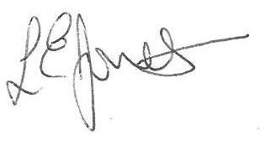

Louise Jones Sean Sly

Executive Head Acting Deputy Head





