
Weekly Newsletter
W.B. 19.2.24

Please can we ask that any reading books taken home are returned to your child’s classroom book boxes after they’ve been used.

This week:

As part of English this week we have started our new focus around poetry. The children listened to the poem ‘What can I build with my blocks?.’ They then performed the poem, analysed it and reordered it. When performing the poem, the children created actions to help them remember the poem and express the language used. They were fantastic at this! When analysing the poem, we looked at the structure and the way a poem is set out, looking carefully at the stanzas, lines and features found within these. When reordering the poem, children had to read the lines given to them and put them into the correct order so the poem made sense.

Can your child tell you the key features of a poem?
Can your child perform the poem to you from memory?

In Maths the children have started to look at number bonds from 10 to 15. The children learned different ways of showing number bonds, for example – with a ten frame, numicon, a shaker tray and part, part, whole. The children worked out what the number bonds were and then wrote the calculations down. For e.g.-

4+6=10
6+4=10
10-4=6
10-6=4

This week we have also learned how to subitise in maths. Subitising is when we can link an image or visual representation to a number. We were shown an image of dots (like the example below) quickly and then it was covered back up, we had to predict how many dots we thought were in the box using our subitising skills.


As part of topic lessons, the children started their Art learning about sculptures. In their first lesson they learnt how to use Modroc by cutting strips, dipping it into water and removing the excess water. They then practised this by screwing up newspaper to make a small ball or horse shoe shape and applying Modroc to it. Later in the week, they got into groups and sculpted their animal face masks with Modroc and then painted them once they were dry. They all looked fantastic!

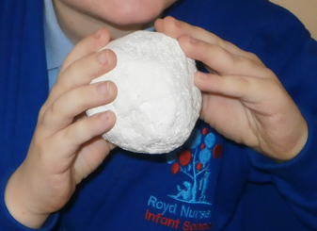
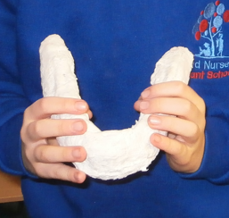
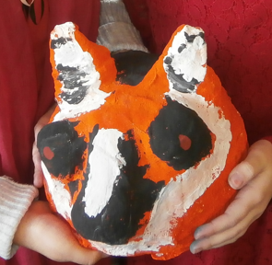

Can your child tell you the steps they took to sculpt their snake?
Reminders:
Class 7 PE days are Monday and Tuesday.
Class 8 PE days are Monday and Tuesday.

Attendance for KS1:
Class 7 – 0%
Class 8 – 0%

Homework
Homework will mainly be handed out on a Wednesday. On the odd occasion it may be on a different day due to timetable changes. Please return homework on a Monday. Handing it on a Monday gives you the opportunity before the weekend to ask the teacher any questions so that you are clear of how to support your child if unsure. There is a tray in each class where the homework needs to be returned. Please ask the teacher where this tray is if unsure.

Spellings
Spellings are handed out each Thursday and your child will be tested on these spellings the following Thursday. Children will receive a list of spellings to practise each week. In addition to the spellings, children will be tested on a sentence containing the words. However, the sentence will not be sent home. This is to see if they can apply the spelling currently within their writing. Can you get your child to practise applying the words by creating their very own sentences?

Reading Diaries
Children in KS1 have all been provided with a Home Reading Diary. Please fill this in daily based on your child reading a couple of pages of a book or a whole book. Please return the Reading Diary to school each day and leave it in the designated classroom tray. There are books situated in the classroom for your child to take home daily. Reading is extremely important to your child’s development so we really encourage your child to read a book or pages of a book daily. If you are unsure of your child’s reading book colour then please ask your teacher.

Thank you
Miss Bamford & Miss Payne

