

Royd Nursery Infant School

Carr Road, Deepcar

Sheffield, S36 2PR

Tel 0114 288 2594

Email [enquiries@royd.sheffield.sch.uk](mailto:enquiries@royd.sheffield.sch.uk)

[www.roydnurseryinfants.co.uk](http://www.roydnurseryinfants.co.uk)

Headteacher: Louise Jones

25 March 2025

Dear Parents / Carers

We would like to invite you in to School for a Stay and Play session with your child on the afternoon of either

* Tuesday pm 29 April 2025 **OR** Thursday pm 8 May 2025

There will be a carousel of activities based on our topic ‘Why is Water Wet?’. The sessions will be from 1.45pm – 2.45pm on both dates.

Should your child not attend provision on Tuesday or Thursday, parents/carers are welcome to join either session and school must be notified of the date you wish to attend. Your child must be accompanied by an adult due to ratio’s.

This is a chance for parent/carers to be involved with their child during school time and therefore, siblings are not allowed at this activity. Please respect this request – thank you.

Please complete and return the slip below or email [enquiries@royd.sheffield.sch.uk](mailto:enquiries@royd.sheffield.sch.uk) if you would like to join us. It would be lovely to see you all.

Yours sincerely,

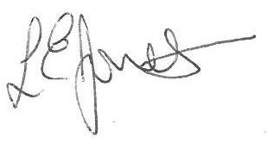

Louise Jones Sean Sly

Executive Head Acting Deputy Head

**Nursery Provision Stay and Play April/May 2025**

**Name of child : Class: FS1**

Yes I / We would like to join you for the Stay and Play

Please select either 29th April pm **OR** 8th May pm

No I / We are unable to attend.

Signed ____________________________________________________ Parent/carer



