
Weekly Newsletter
W.B. 27.1.25

This week:

As part of English this week we have continued our story writing. The children have learnt about the prefix ‘un’ which is added to the start of a root word to change the meaning by giving it an opposite/negative force. We can often say the opposite of a word by adding ‘un’ for example, kind = unkind and friendly = unfriendly. There are no spelling rules for adding the prefix ‘un’ so the children simply applied it to the start of a bank of words and then used these within their sentence writing.

After that, children created a story plan including pictures and key words to support them when writing their story based on the short film ‘So Good to Me’.

Can your child re-tell you the ‘start’ of their story?
Can your child tell you the story language we use for the ‘build up’ of a story?

In Maths we recorded the volume of liquid in a range of containers by correctly reading the measurements and recording the amount in millilitres (ml) or litres (l). We then discussed that if you don’t know the exact volume of something in a container, then you can still describe the volume using the adjectives full, half full and empty.

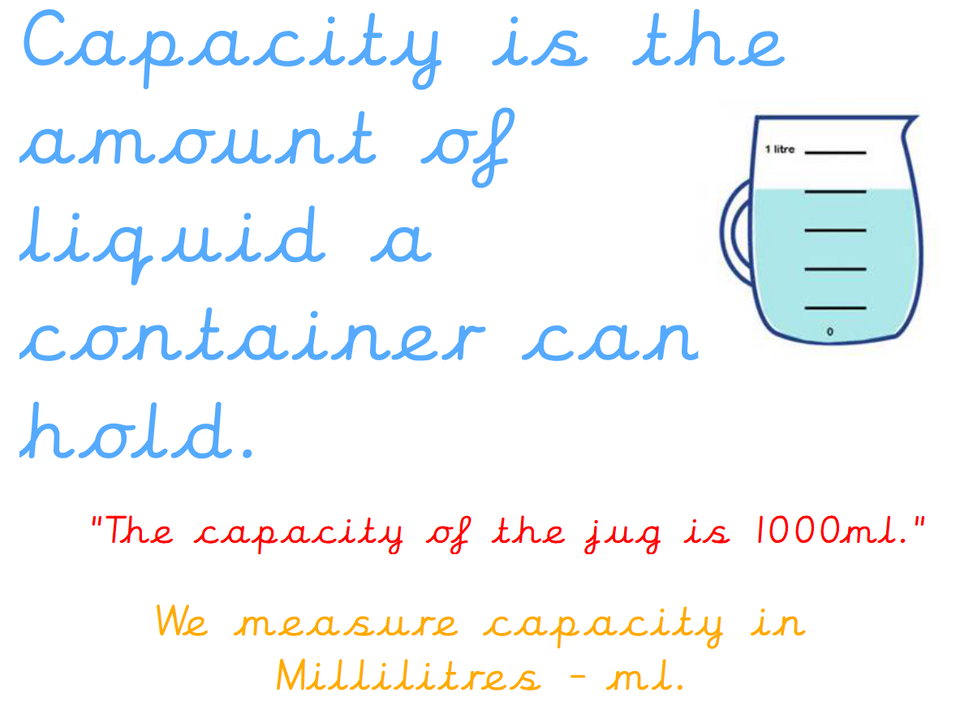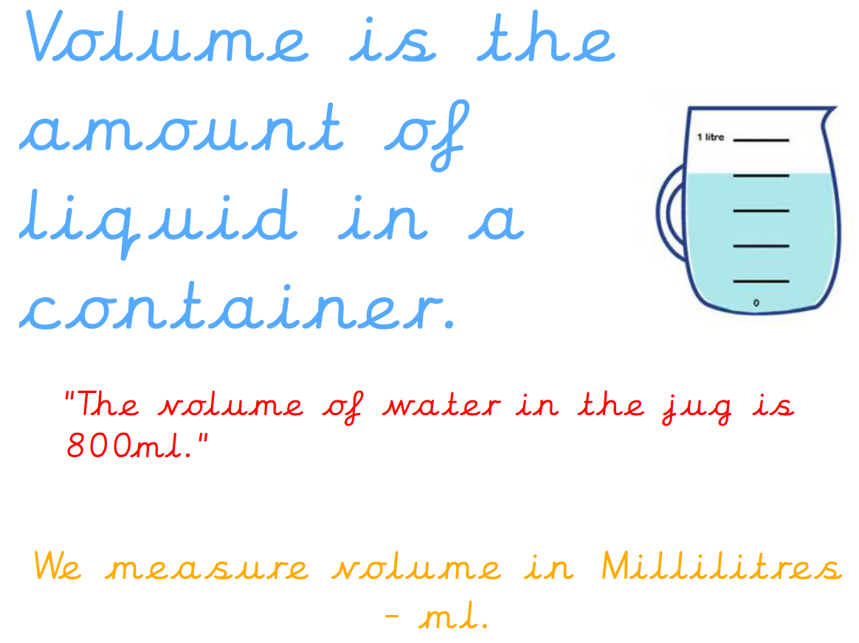

Can your child record under each glass whether the volume is full, half full or empty?



This week has been safety week! Children have completed a series of activities linked to keeping safe. They received a visit from a firefighter about fire safety, a police officer to talk about stranger danger and they had a visit from an A+E nurse. The children also visited Jackie, our lovely lollipop lady who taught us all about road safety and the essential steps to take when crossing a road. The children then completed lots of activities related to this including a ‘’stop drop roll’ poster for fire safety, identifying trusted adults in our neighbourhood, instructions for crossing the road and much more!

Can your child tell you the most interesting fact they’ve learnt from safety week this week?

Reminders:
Class 7 PE day (indoor and outdoor) is Thursday.
Class 8 PE days are Wednesday (outdoors) and Thursday (indoors).
Class 9 PE day (indoor and outdoor) is Thursday.

Children need a t-shirt, shorts (for indoor PE), long trousers (for outdoor PE), trainers and a jumper in their PE bags.

Attendance for KS1:
Class 7 – 97.4%
Class 8 – 97.9%
Class 9 – 99.3%

Homework
Homework will mainly be handed out on a Tuesday. On the odd occasion it may be on a different day due to timetable changes. Please return homework on a Monday. Handing it on a Monday gives you the opportunity before the weekend to ask the teacher any questions so that you are clear of how to support your child if unsure. There is a tray in each class where the homework needs to be returned. Please ask the teacher where this tray is if unsure.

Spellings
No spellings were handed out this week as new groups will be given in the first week back.

Reading Diaries
Children in KS1 have all been provided with a Home Reading Diary. Please fill this in daily based on your child reading a couple of pages of a book or a whole book. Please return the Reading Diary to school each day and leave it in their book bags. There are books situated in the classroom for your child to take home daily. Reading is extremely important to your child’s development so we really encourage your child to read a book or pages of a book daily. If you are unsure of your child’s reading book colour then please ask your teacher.

Online Safety
The below has been taken from GOV.UK and is guidance based on “Support for parents and carers to keep children safe online”.
While there are huge benefits to being online to stay connected to family and friends, the government recognises many parents feel concerned about the activities and content their children are accessing. This guidance outlines resources to help keep children safe from different risks online and where to go to get support and advice.
Keep your child safe online
It is important to have regular conversations about staying safe online and to encourage children to speak to you if they come across something worrying online.
Talk to your child about the importance of creating a safe online environment, including keeping any log-in details and passwords safe.
The below resource is designed to support you to talk to your child about a range of online safety issues, set up home filtering in a child-friendly way and set up age-appropriate parental controls on digital devices:
The Children’s Commissioner has published advice for parents on talking to your child about online sexual harassment specifically, based on input from children themselves https://www.childrenscommissioner.gov.uk/resource/talking-to-your-child-about-online-sexual-harassment-a-guide-for-parents/

Thank you
Miss Payne, Miss Howes & Miss Aldam

