

Royd Nursery Infant School

Carr Road, Deepcar

Sheffield, S36 2PR

Tel 0114 288 2594

Email [enquiries@royd.sheffield.sch.uk](mailto:enquiries@royd.sheffield.sch.uk)

[www.roydnurseryinfants.co.uk](http://www.roydnurseryinfants.co.uk)

Headteacher: Louise Jones

28 February 2025

Dear Parent/Carers,

On Tuesday 25 March 2025 we are having a ‘Learn a New Skill’ afternoon for the children and would like to invite you in to School to join in the activities with your child.

The activities are mini first aid, tam building and archery with 30 minutes at each session before moving on to the next skill.

Parent/carers need to arrive at school at 1pm for a prompt 1.15pm start and will need to wear suitable footwear. The event will finish at 3.15pm.

If you would like to join us please complete and return the slip below. We look forward to seeing you all.

Yours sincerely,

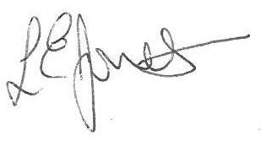

Louise Jones Sean Sly

Executive Head Acting Deputy Head

**Learn A New Skill KS1 Tuesday 25 March 2025**

Name of child: Class

YES I/We would love to attend the learn a new skill afternoon.

NO I/We will not be attending.

Signed ____________________________________________________ Parent/carer



