

Royd Nursery Infant School

Carr Road, Deepcar

Sheffield, S36 2PR

Tel 0114 288 2594

Email [enquiries@royd.sheffield.sch.uk](mailto:enquiries@royd.sheffield.sch.uk)

[www.roydnurseryinfants.co.uk](http://www.roydnurseryinfants.co.uk)

Headteacher: Louise Jones

31 January 2025

Dear Parents/Carers

For children in FS2, Y1 and Y2 we are running several extra curricular activities during the Spring 2 half term.

The clubs are remaining the same and on the same days.

For your child to attend, you will need to log on to Parentpay then select and pay for the club/s you wish your child to attend. This will be on a first come first served basis and the places become available later today.

Yours sincerely,

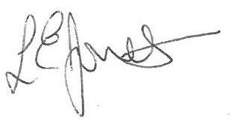

Louise Jones Sean Sly

Executive Head Acting Deputy Head

-------------------------------------------------------------------------------------------------------------------

**Extra Curricular Activities Spring 2 2025**

**Monday**

Learning new FS2/Y1/Y2 3.20pm – 4.20pm 24 Feb – 24 Mar £22.50

Sports

**Tuesday**

Dance FS2/Y1/Y2 3.20pm – 4.20pm 25 Feb – 25 Mar £22.50

**Wednesday**

Football Y1//Y2 3.30pm – 4.30pm 26 Feb – 26 Mar £22.50

**Friday**

FUNdamentals FS2/Y1/Y2 3.20pm – 4.20 pm 28 Feb – 28 Mar £22.50





