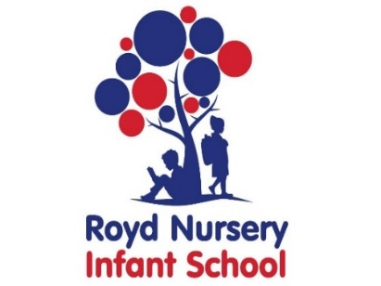

Royd Nursery Infant School

Carr Road, Deepcar

Sheffield, S36 2PR

Tel 0114 288 2594

Email [enquiries@royd.sheffield.sch.uk](mailto:enquiries@royd.sheffield.sch.uk)

[www.roydnurseryinfants.co.uk](http://www.roydnurseryinfants.co.uk)

Headteacher: Louise Jones

13 February 2025

Dear Parents/Carers

For children in FS2, Y1 and Y2 another extra curricular club for Thursday will be available for the Spring 2 half term. It will run for 5 weeks beginning Thursday 27 February 2025 from 3.20 pm – 4.20 pm.

Clay work and paint is being run by Rachel Wood from The Kiln based in Stocksbridge. Each week children will paint a piece of pottery. This will then be left with Rachel to be fired in a kiln. Children will then receive this back the week after to take home.

This is expected to be a very popular workshop and places will be split equally between each year group. For your child to attend, you will need to log on to Parentpay then select and pay for the club according to your childs year group;

* The Kiln FS2 Spring 2025
* The Kiln Year 1 Spring 2025
* The Kiln Year 2 Spring 2025

This will be on a first come first served basis and the places become available from 4pm today.

Yours sincerely,

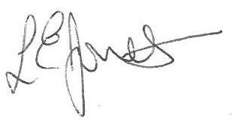

Louise Jones Sean Sly

Executive Head Acting Deputy Head



