
Weekly Newsletter
W.B. 13.1.25

This week:

As part of English this week the children have continued their second cycle of story writing. The children have been using the learning wall and their own ideas to create a bank of ambitious vocabulary they can transfer in their story writing. We looked more closely at adjectives (describing words) for example, ginormous and elegant. We also looked at verbs (doing words) for example, darted and spotted.
The children then used the coordinating conjunctions (and, but, or) and subordinating conjunctions (because, when if) in their sentence writing. A coordinating conjunction joins two simple sentences/independent clauses together.

Can your child tell you what an adjective is? Can your child tell you what a verb is?

Can your child write a sentence about Sarah (the girl in our video story stimulus) using an adjective and a verb?
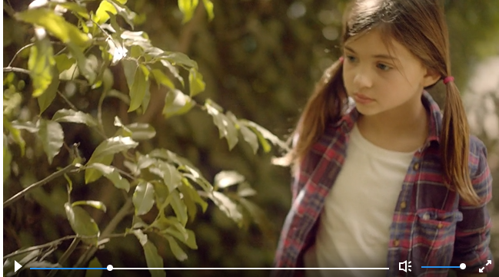

In Maths this week the children have continued their work around space, shape and measure. The children have started looking at time. The children have been working on both analogue clocks and digital clocks, looking carefully at the minute hand and the hour hand to tell the time. The children have been measuring the time this week looking at o’clock, half past, quarter to and quarter past on both clocks. The children have loved this and have done so well!

Can your child tell the time at home?
Can they tell you what the time will be an hour later?
Can they tell you what the time will be half an hour later?
Can they identify the hour hand and the minute hand on the clock?

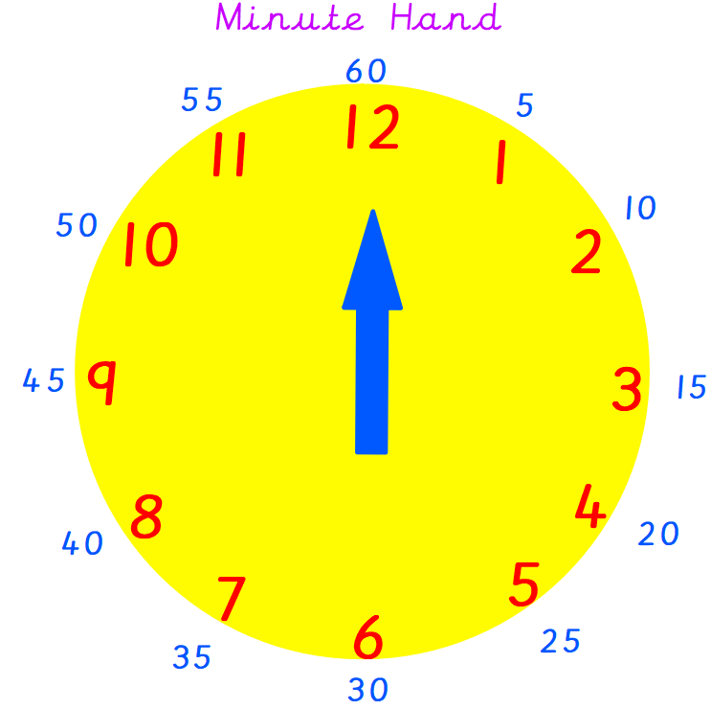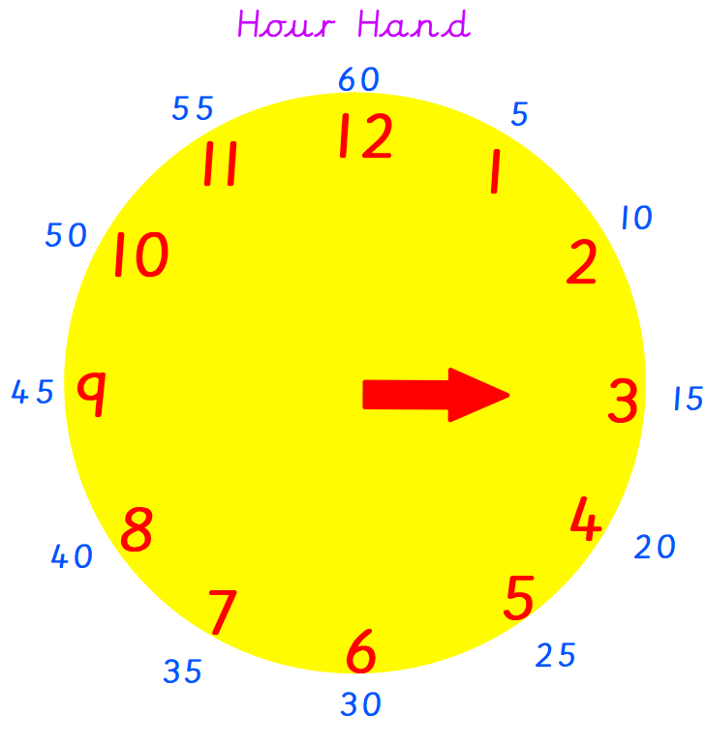
The minute hand is longer than the hour hand.

The children’s topic this half term is ‘Beat Band Boogie’. As part of topic lessons, children have started their science learning. They have learnt about animals from the local environment and wider environment and named them. We then learnt about the six main classification groups; invertebrates, fish, amphibians, birds, reptiles and mammals. Children had to identify the animal and then sort it into the correct group by identifying their key features. For example, the children know that invertebrates don’t have a backbone and that mammals either have fur or hair.
Can your child tell you an animal from each of the six classification groups?
Reminders:
Class 7 PE day (indoor and outdoor) is Thursday.
Class 8 PE days are Wednesday (outdoors) and Thursday (indoors).
Class 9 PE day (indoor and outdoor) is Thursday.

Children need a t-shirt, shorts (for indoor PE), long trousers (for outdoor PE), trainers and a jumper in their PE bags.

Attendance for KS1:
Class 7 – 97.4%
Class 8 – 99%
Class 9 – 99.3%

Homework
Homework will mainly be handed out on a Tuesday. On the odd occasion it may be on a different day due to timetable changes. Please return homework on a Monday. Handing it on a Monday gives you the opportunity before the weekend to ask the teacher any questions so that you are clear of how to support your child if unsure. There is a tray in each class where the homework needs to be returned. Please ask the teacher where this tray is if unsure.

Spellings
No spellings were handed out this week as new groups will be given in the first week back.

Reading Diaries
Children in KS1 have all been provided with a Home Reading Diary. Please fill this in daily based on your child reading a couple of pages of a book or a whole book. Please return the Reading Diary to school each day and leave it in their book bags. There are books situated in the classroom for your child to take home daily. Reading is extremely important to your child’s development so we really encourage your child to read a book or pages of a book daily. If you are unsure of your child’s reading book colour then please ask your teacher.

Online Safety
The below has been taken from GOV.UK and is guidance based on “Support for parents and carers to keep children safe online”.
While there are huge benefits to being online to stay connected to family and friends, the government recognises many parents feel concerned about the activities and content their children are accessing. This guidance outlines resources to help keep children safe from different risks online and where to go to get support and advice.
Keep your child safe online
It is important to have regular conversations about staying safe online and to encourage children to speak to you if they come across something worrying online.
Talk to your child about the importance of creating a safe online environment, including keeping any log-in details and passwords safe.
The below resource is designed to support you to talk to your child about a range of online safety issues, set up home filtering in a child-friendly way and set up age-appropriate parental controls on digital devices:
Inclusive Digital Safety Hub and Online Safety Hub, created by South West Grid for Learning in partnership with Internet Matters - support and tailored advice for young people with additional learning needs and their parents or carers https://www.internetmatters.org/inclusive-digital-safety/ AND https://www.internetmatters.org/connecting-safely-online/

Thank you
Miss Payne, Miss Howes & Miss Aldam

