
Weekly Newsletter
W.B. 8.1.24

Please can we ask that any reading books taken home are returned to your child’s classroom book boxes after they’ve been used.

This week:

As part of English this week the children have started their second cycle of story writing. Our story writing this half term is based on the short Pixar film ‘For the birds’ which focuses on bullying. The children discussed the main character and setting in the story as well as the story language used to set the scene. We then acted out the story and did some hot-seating where we thought about what it must have felt like to be Harry (our main character – the bigger bird). This deepened the children’s understanding of the story and the purpose!

Can you ask your child to act out the ‘For the birds’ story to you?

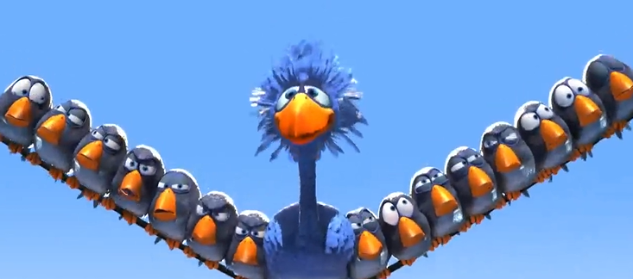

As part of Maths this week children have continued with their shape, space and measure learning. We have continued learning about mass.
The children know when we are measuring how light or heavy an object is, we are measuring its mass. We measure mass in grams (g) and kilograms (kg).

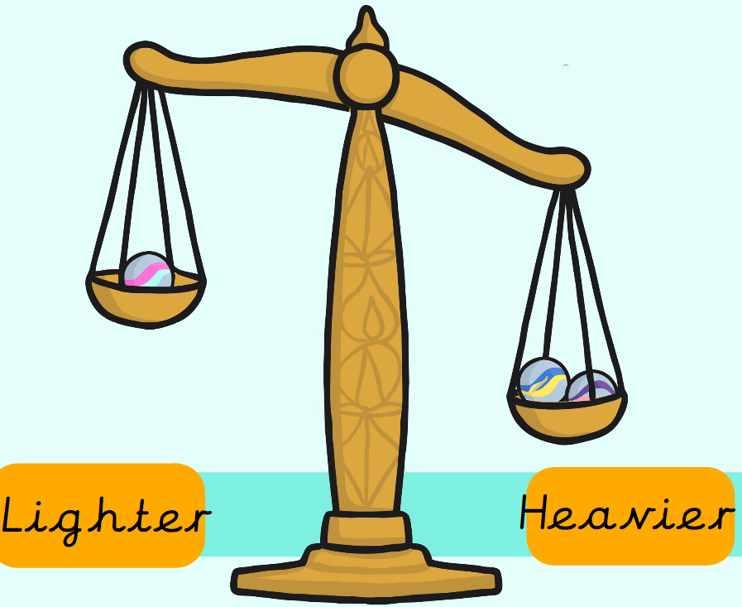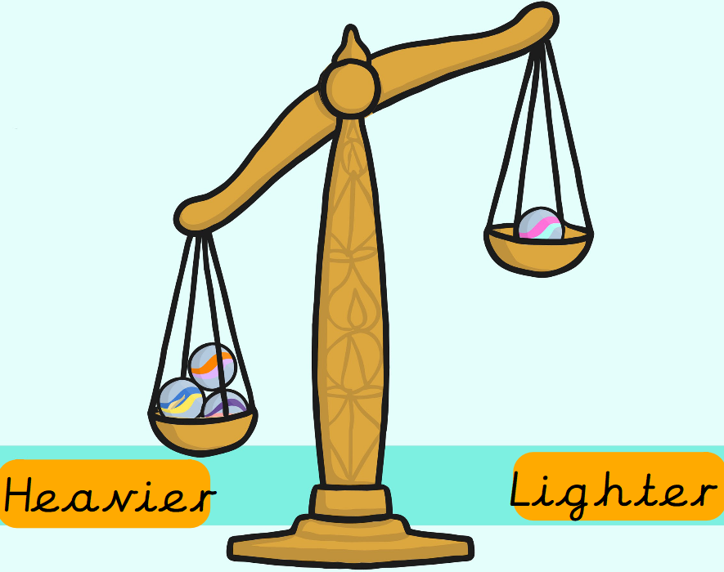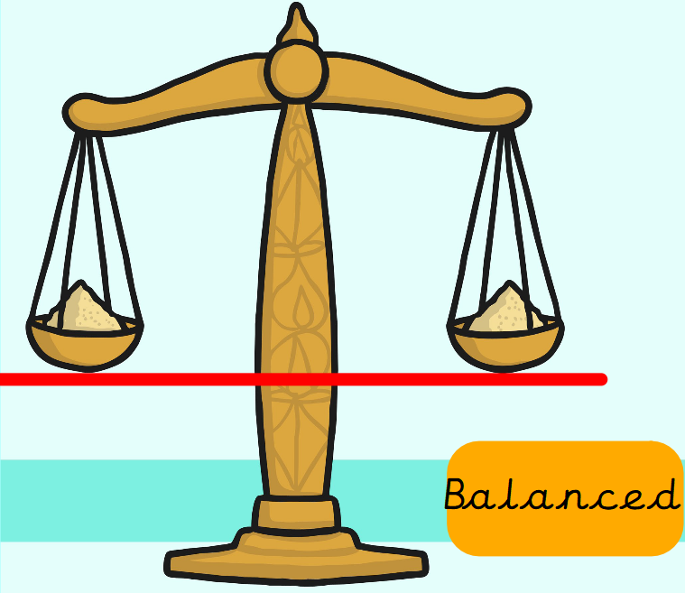

Can your child find two items at home and compare their mass? Which one do they predict will be heavier/lighter?
Can your child find two items they predict may have the same mass?
We measure mass in grams (g) and kilograms (kg). We have compared the mass of items by weighing them using balancing scales and recording whether they are lighter than < heavier than > or balanced =

We then learnt to read scales. We had to check what each little line was worth first on the scale because it doesn’t always count in ones! Once we had worked that out we recorded the total mass using grams (g) as our correct measurement.

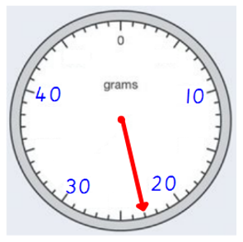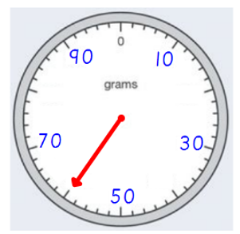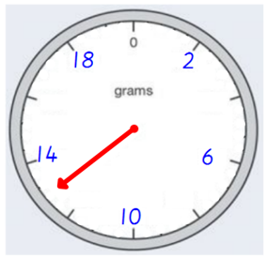

Can your child record the total mass being shown on the scales above?

The children’s topic this half term is ‘Rio De Vida’. As part of topic lessons, children have started their Science learning. They have learnt about animals in the local environment. We then learnt about the six main classification groups; invertebrates, fish, amphibians, birds, reptiles and mammals. Children had to identify the animal and then sort it into the correct group by identifying their key features. For example, the children know that invertebrates don’t have a backbone and that mammals either have fur or hair.

Can your child tell you an animal from each of the six classification groups?

Reminders:
Class 8 PE days are Monday and Tuesday.
Class 9 PE days are Monday and Wednesday.

Attendance for KS1:
Class 8 – 96.2%
Class 9 – 97.8%

Homework
Homework will mainly be handed out on a Wednesday. On the odd occasion it may be on a different day due to timetable changes. Please return homework on a Monday. Handing it on a Monday gives you the opportunity before the weekend to ask the teacher any questions so that you are clear of how to support your child if unsure. There is a tray in each class where the homework needs to be returned. Please ask the teacher where this tray is if unsure.

Spellings
Spellings are handed out each Thursday and your child will be tested on these spellings the following Thursday. Children will receive a list of spellings to practise each week. In addition to the spellings, children will be tested on a sentence containing the words. However, the sentence will not be sent home. This is to see if they can apply the spelling currently within their writing. Can you get your child to practise applying the words by creating their very own sentences?

Reading Diaries
Children in KS1 have all been provided with a Home Reading Diary. Please fill this in daily based on your child reading a couple of pages of a book or a whole book. Please return the Reading Diary to school each day and leave it in the designated classroom tray. There are books situated in the classroom for your child to take home daily. Reading is extremely important to your child’s development so we really encourage your child to read a book or pages of a book daily. If you are unsure of your child’s reading book colour then please ask your teacher.

Thank you
Miss Rawding & Miss Payne

