

Royd Nursery Infant School

Carr Road, Deepcar

Sheffield, S36 2PR

Tel 0114 288 2594

Email [enquiries@royd.sheffield.sch.uk](mailto:enquiries@royd.sheffield.sch.uk)

[www.roydnurseryinfants.co.uk](http://www.roydnurseryinfants.co.uk)

Headteacher: Louise Jones

14 January 2025

Dear Parents / Carers

We would like to invite you in to School for a Stay and Play session with your child on Friday 31st January 2025.

There will be a carousel of activities, where the children will be able to explore and investigate with different materials. The session will be from 8:50am until 9:50am.

Please either call or email Mrs Stuart [enquiries@royd.sheffield.sch.uk](mailto:enquiries@royd.sheffield.sch.uk) if you would like to join us, it would be lovely to see you all.

Yours sincerely,

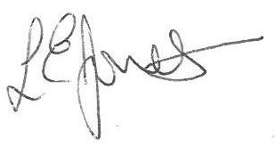

Louise Jones Sean Sly

Executive Head Acting Deputy





