

Royd Nursery Infant School

Carr Road, Deepcar

Sheffield, S36 2PR

Tel 0114 288 2594

Email [enquiries@royd.sheffield.sch.uk](mailto:enquiries@royd.sheffield.sch.uk)

[www.roydnurseryinfants.co.uk](http://www.roydnurseryinfants.co.uk)

Headteacher: Louise Jones

14 January 2025

Dear Parents / Carers

We would like to invite you in to School for a Stay and Play session with your child on

* Tuesday am 28th January 2025 OR
* Wednesday pm 29th January 2025

There will be a carousel of activities where children will be able to explore and investigate different materials. The sessions will be from 9.15am – 10.00am on Tuesday 28th January or 2:15 pm until 3:00 pm Wednesday 29th January.

Should your child not attend provision on Tuesday or Wednesday, parents/carers are welcome to join either session and school must be notified of the date you wish to attend. Your child must be accompanied by an adult due to ratio’s.

Please either call or email Mrs Stuart [enquiries@royd.sheffield.sch.uk](mailto:enquiries@royd.sheffield.sch.uk) if you would like to join us, it would be lovely to see you all.

Yours sincerely,

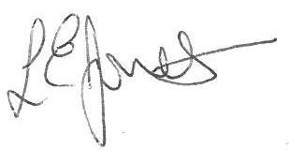

Louise Jones Sean Sly

Executive Head Acting Deputy Head



