
Weekly Newsletter
W.B. 2.12.24

A reminder that your child’s Christmas play costume should be in school by Thursday 5th December.
Key Stage 1 Christmas play will take place on Wednesday 11th December at 10am and 2pm.

This week:
As part of English this week the children have continued their new writing genre; information text. The children wrote their improvement sentences and then analysed their writing against the steps for success. These included: heading, subheading, paragraphs and technical words.

Can your child tell you their improvement sentence?

As part of Maths this week children have continued with their shape, space and measure learning. The children have been learning about mass and how to read scales. First the children worked out what the scales were counting in, they then filled in the missing numbers and from that they could then work out what the mass was. Children also enjoyed being given the measurement and drawing the arrow on themselves to show what the mass is.

Can your child tell you how many kg are in 1000g?

The children’s topic this half term is ‘Towers, Tunnels and Turrets’. As part of topic lessons, children have continued with their Design and Technology learning. After learning how to correctly join materials in their last lesson, it was time for the children to design their own castle frontage! They drew the outline of their castle before labelling the different parts with what materials they would be using and how they would be joining it. The children then had to carefully select the materials they needed to make their castle frontage.

Can your child tell you the process they took to design and create their castle frontage?

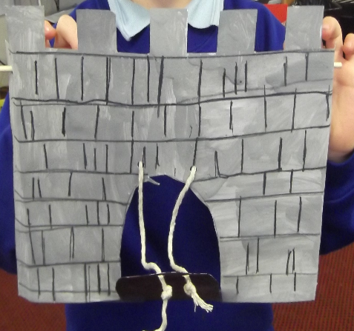

Reminders:
Class 7 PE day (indoor and outdoor) is Thursday.
Class 8 PE days are Wednesday (outdoors) and Thursday (indoors).
Class 7 PE day (indoor and outdoor) is Thursday.

Children need a t-shirt, shorts (for indoor PE), long trousers (for outdoor PE), trainers and a jumper in their PE bags.

Attendance for KS1:
Class 7 – 96.5%
Class 8 – 95.5%
Class 9 – 95.4%

Homework
Homework will mainly be handed out on a Tuesday. On the odd occasion it may be on a different day due to timetable changes. Please return homework on a Monday. Handing it on a Monday gives you the opportunity before the weekend to ask the teacher any questions so that you are clear of how to support your child if unsure. There is a tray in each class where the homework needs to be returned. Please ask the teacher where this tray is if unsure.
Spellings
Spellings are handed out each Thursday and your child will be tested on these spellings the following Thursday. Children will receive a list of spellings to practise each week. In addition to the spellings, children will be tested on a sentence containing the words. However, the sentence will not be sent home. This is to see if they can apply the spelling currently within their writing. Can you get your child to practise applying the words by creating their very own sentences?

Reading Diaries
Children in KS1 have all been provided with a Home Reading Diary. Please fill this in daily based on your child reading a couple of pages of a book or a whole book. Please return the Reading Diary to school each day and leave it in their book bags. There are books situated in the classroom for your child to take home daily. Reading is extremely important to your child’s development so we really encourage your child to read a book or pages of a book daily. If you are unsure of your child’s reading book colour then please ask your teacher.

Online Safety
The below has been taken from GOV.UK and is guidance based on “Support for parents and carers to keep children safe online”.
While there are huge benefits to being online to stay connected to family and friends, the government recognises many parents feel concerned about the activities and content their children are accessing. This guidance outlines resources to help keep children safe from different risks online and where to go to get support and advice.
Keep your child safe online
It is important to have regular conversations about staying safe online and to encourage children to speak to you if they come across something worrying online.
Talk to your child about the importance of creating a safe online environment, including keeping any log-in details and passwords safe.
The below resource is designed to support you to talk to your child about a range of online safety issues, set up home filtering in a child-friendly way and set up age-appropriate parental controls on digital devices:
Childnet has developed guidance for parents and carers to begin a conversation about online safety, as well as guidance on keeping under-fives safe online https://www.childnet.com/parents-and-carers/have-a-conversation/ AND https://www.childnet.com/help-and-advice/keeping-young-children-safe-online/

Thank you
Miss Payne, Miss Howes & Miss Aldam

