
Weekly Newsletter
W.B. 25.11.24

A reminder that your child’s Christmas play costume should be in school by Thursday 5th December.
Key Stage 1 Christmas play will take place on Wednesday 11th December at 10am and 2pm.

This week:
As part of English this week the children have continued their new writing genre; information text. The children started the week by planning their information text by writing key bullet points about castles. They were then ready to get creative and start writing their information text over the next two lessons.
The children remembered all of the key elements including, heading, subheading, paragraphs and technical words to do with the subject. They also remembered their capital letters, full stops and even used some technical words!

Can your child tell you an interesting fact about castles?

As part of Maths this week children have continued learning about 2D shapes and 3D shapes and discussed their properties, such as how many vertices, edges and faces they have.

Please look at the information below with your child:

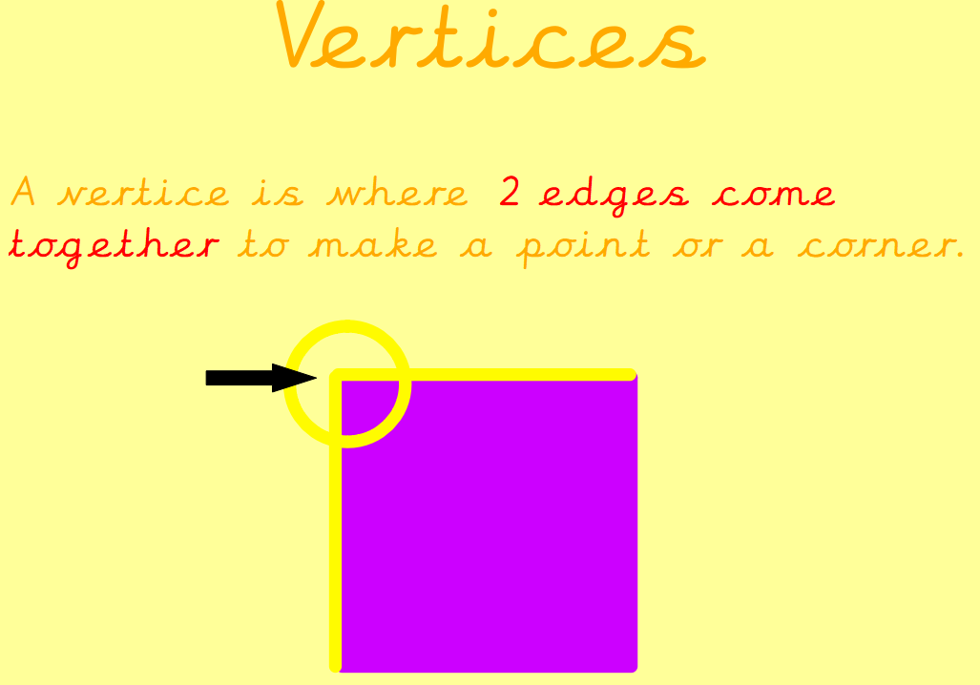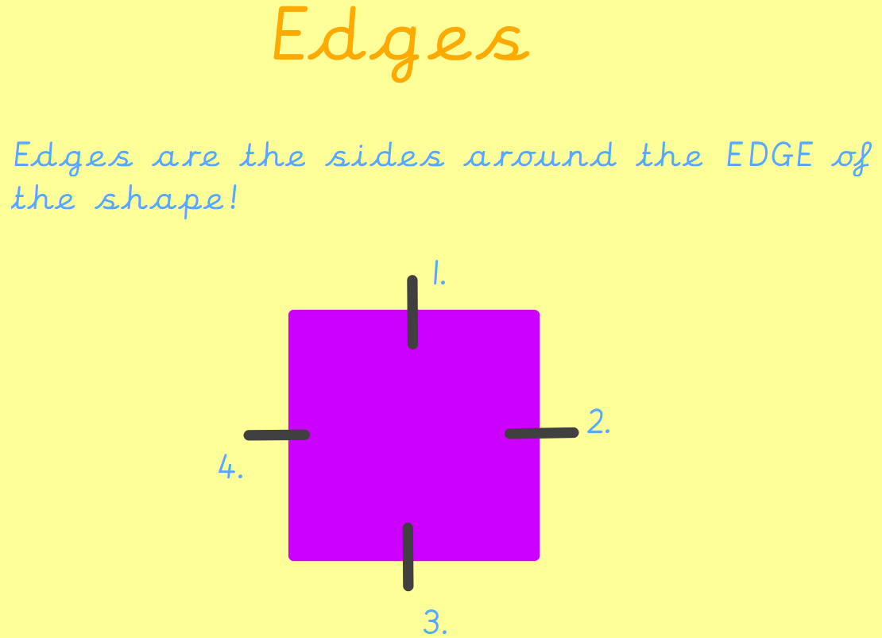

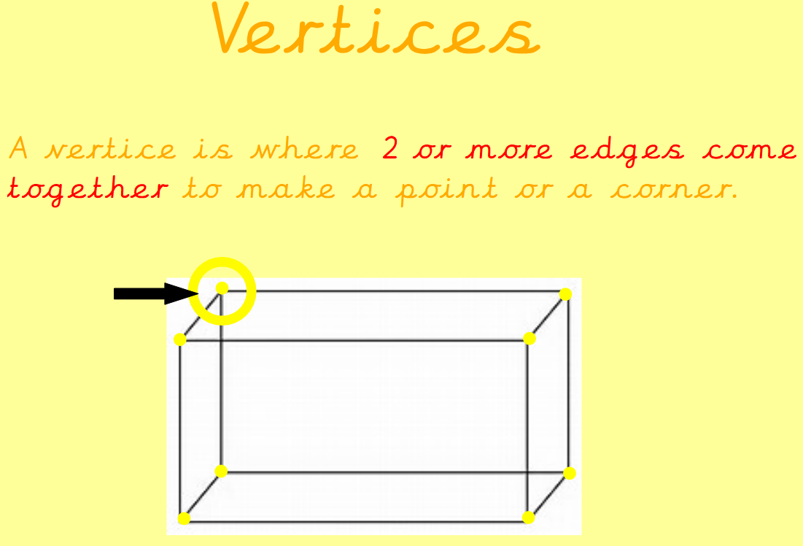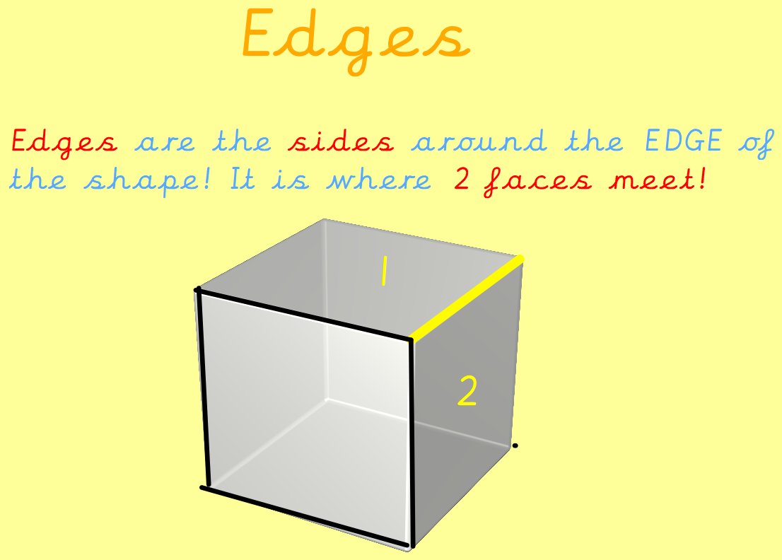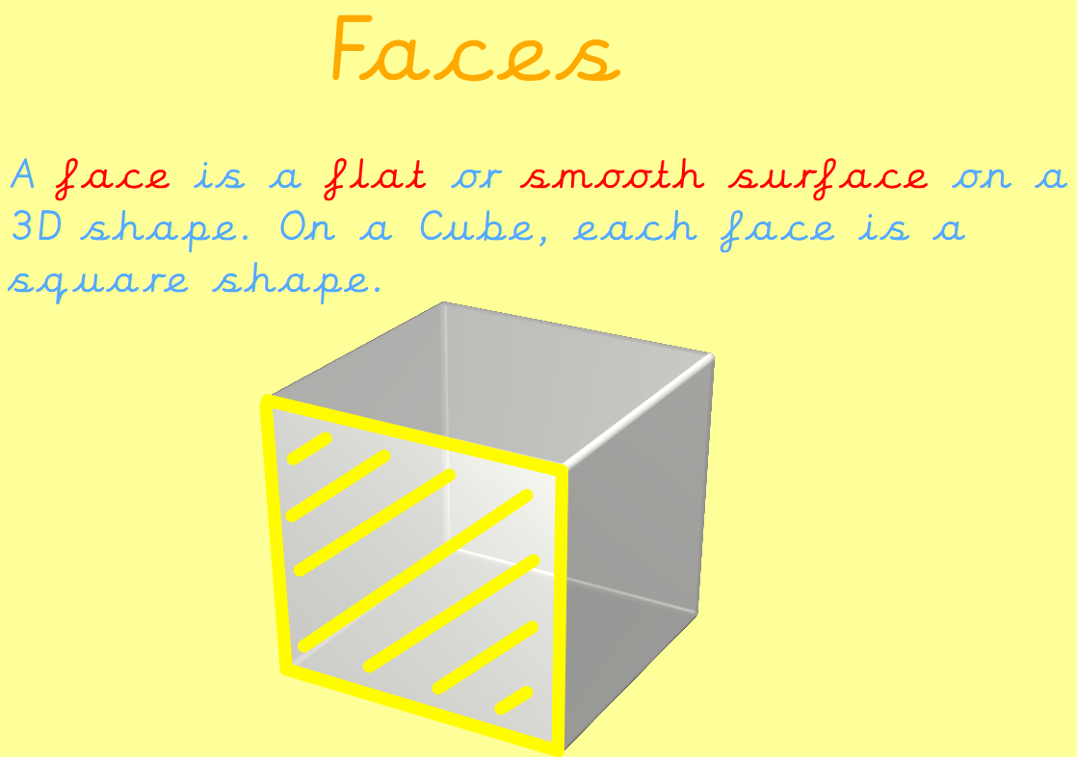

Can your child tell you the properties of these shapes?
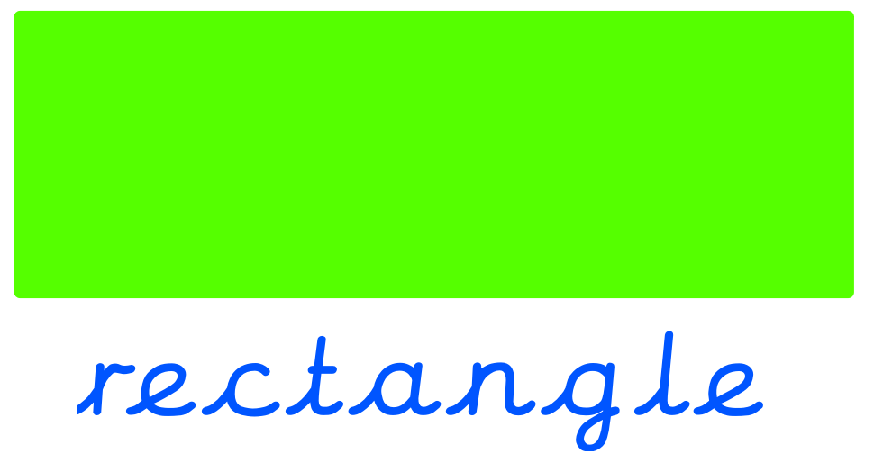

Reminders:
Class 7 PE day (indoor and outdoor) is Thursday.
Class 8 PE days are Wednesday (outdoors) and Thursday (indoors).
Class 7 PE day (indoor and outdoor) is Thursday.

Children need a t-shirt, shorts (for indoor PE), long trousers (for outdoor PE), trainers and a jumper in their PE bags.

Attendance for KS1:
Class 7 – 98.3%
Class 8 – 93.1%
Class 9 – 93.9%

Homework
Homework will mainly be handed out on a Tuesday. On the odd occasion it may be on a different day due to timetable changes. Please return homework on a Monday. Handing it on a Monday gives you the opportunity before the weekend to ask the teacher any questions so that you are clear of how to support your child if unsure. There is a tray in each class where the homework needs to be returned. Please ask the teacher where this tray is if unsure.

Spellings
Spellings are handed out each Thursday and your child will be tested on these spellings the following Thursday. Children will receive a list of spellings to practise each week. In addition to the spellings, children will be tested on a sentence containing the words. However, the sentence will not be sent home. This is to see if they can apply the spelling currently within their writing. Can you get your child to practise applying the words by creating their very own sentences?

Reading Diaries
Children in KS1 have all been provided with a Home Reading Diary. Please fill this in daily based on your child reading a couple of pages of a book or a whole book. Please return the Reading Diary to school each day and leave it in their book bags. There are books situated in the classroom for your child to take home daily. Reading is extremely important to your child’s development so we really encourage your child to read a book or pages of a book daily. If you are unsure of your child’s reading book colour then please ask your teacher.

Online Safety
The below has been taken from GOV.UK and is guidance based on “Support for parents and carers to keep children safe online”.

While there are huge benefits to being online to stay connected to family and friends, the government recognises many parents feel concerned about the activities and content their children are accessing. This guidance outlines resources to help keep children safe from different risks online and where to go to get support and advice.

Keep your child safe online
It is important to have regular conversations about staying safe online and to encourage children to speak to you if they come across something worrying online.

Talk to your child about the importance of creating a safe online environment, including keeping any log-in details and passwords safe.

The below resource is designed to support you to talk to your child about a range of online safety issues, set up home filtering in a child-friendly way and set up age-appropriate parental controls on digital devices:

Thinkuknow by the National Crime Agency - Child Exploitation and Online Protection command (NCA-CEOP) - resources for parents and carers and children of all ages to help keep children safe online
https://www.ceopeducation.co.uk/

Thank you
Miss Payne, Miss Howes & Miss Aldam

