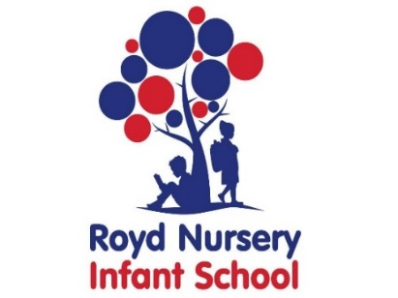

Royd Nursery Infant School

Carr Road, Deepcar

Sheffield, S36 2PR

Tel 0114 288 2594

Email [enquiries@royd.sheffield.sch.uk](mailto:enquiries@royd.sheffield.sch.uk)

[www.roydnurseryinfants.co.uk](http://www.roydnurseryinfants.co.uk)

Headteacher: Louise Jones

6 December 2024

Dear Parent/Carers,

Our topic in Year 1 and 2 will be Beat Band Boogie and we have arranged for Music Specialists from the Sheffield Music Hub to work with the children on African music.

The event will be on Friday 10 January 2025 and the contribution is £6.90 per child.

If you would like your child to take part contribution and consent is via Parentpay. Please complete this by Monday 6 January 2025. If there are any issues please do not hesitate to contact Mr Sly.

Thank you.

Yours sincerely,



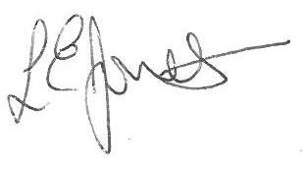

Louise Jones Sean Sly

Executive Head Acting Deputy Head



