
Weekly Newsletter
W.B. 18.11.24

This week:
As part of English this week the children have continued their new writing genre; information text. The children started the week by planning their information text by writing key bullet points for different features of a castle. They were then ready to get creative and start writing their information text over the next two lessons.
The children remembered all of the key elements including, heading, subheading, paragraphs and technical words to do with the subject. They also remembered their capital letters, full stops and even used ambitious words!

Can your child tell you an interesting fact about castles?

As part of Maths this week children have been learning to read and write numbers in numerals and words. They have worked really hard to recognise numbers, read numbers and correctly form and spell them. Using the word bank below can your child write the following numbers either in words or numerals?

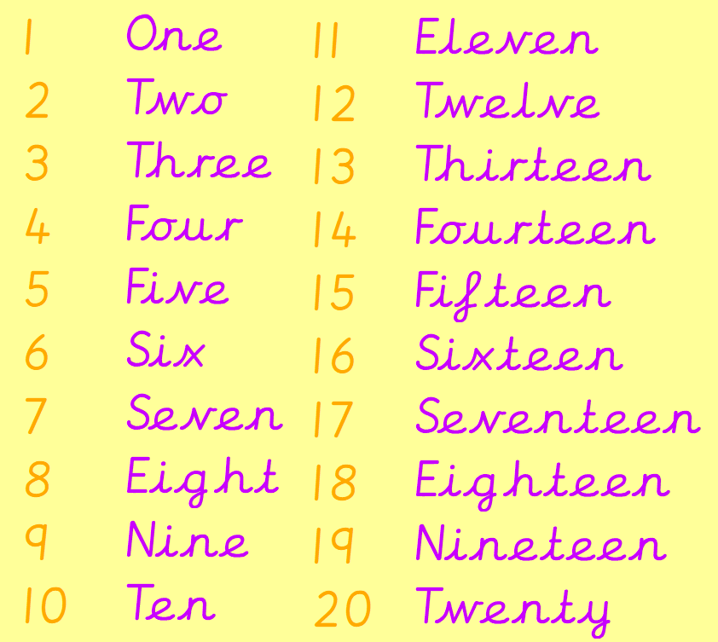

9 ________

Twelve ____

16 ________

Five ____

The children’s topic this half term is ‘Towers, Tunnels and Turrets’. In our Design and Technology learning we have focused on practising our cutting; a very important skill! The children learnt the correct way to hold the scissors before applying these skills to cut a range of lines and shapes. In our next lesson, we learnt about joining techniques. The children loved exploring using techniques such as ‘flange’, ‘slot’ and ‘tabs’ to prepare them for designing and creating their very own castle frontage!

Can your child demonstrate how to correctly cut a range of materials?
Can your child tell you which techniques they used to accurately join their materials?

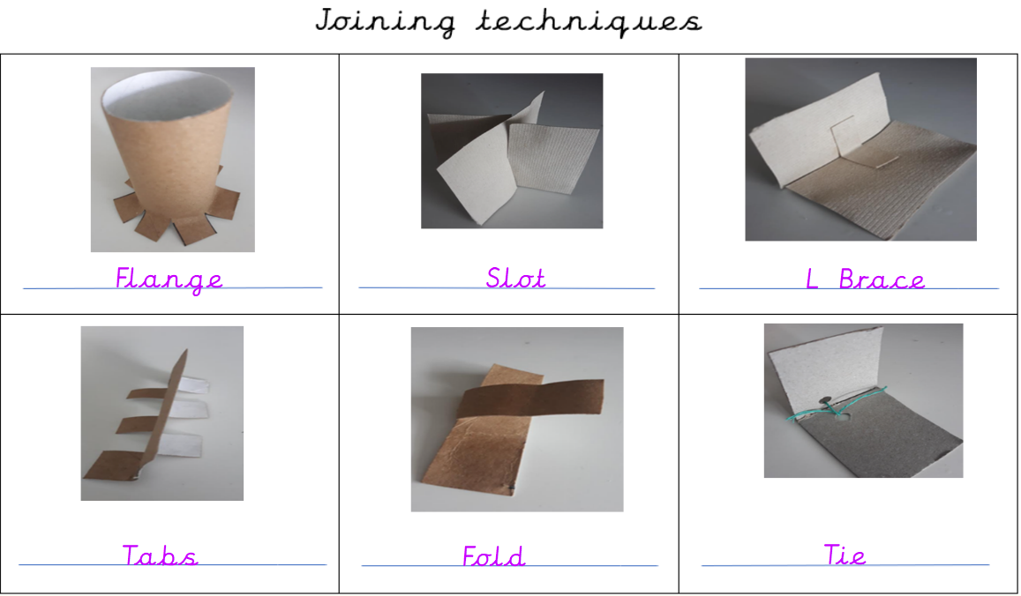

Reminders:
Class 7 PE day (indoor and outdoor) is Thursday.
Class 8 PE days are Wednesday (outdoors) and Thursday (indoors).
Class 7 PE day (indoor and outdoor) is Thursday.

Children need a t-shirt, shorts (for indoor PE), long trousers (for outdoor PE), trainers and a jumper in their PE bags.

Attendance for KS1:
Class 7 – 95.2%
Class 8 – 92.9%
Class 9 – 96.9%

Homework
Homework will mainly be handed out on a Tuesday. On the odd occasion it may be on a different day due to timetable changes. Please return homework on a Monday. Handing it on a Monday gives you the opportunity before the weekend to ask the teacher any questions so that you are clear of how to support your child if unsure. There is a tray in each class where the homework needs to be returned. Please ask the teacher where this tray is if unsure.

Spellings
Spellings are handed out each Thursday and your child will be tested on these spellings the following Thursday. Children will receive a list of spellings to practise each week. In addition to the spellings, children will be tested on a sentence containing the words. However, the sentence will not be sent home. This is to see if they can apply the spelling currently within their writing. Can you get your child to practise applying the words by creating their very own sentences?

Reading Diaries
Children in KS1 have all been provided with a Home Reading Diary. Please fill this in daily based on your child reading a couple of pages of a book or a whole book. Please return the Reading Diary to school each day and leave it in their book bags. There are books situated in the classroom for your child to take home daily. Reading is extremely important to your child’s development so we really encourage your child to read a book or pages of a book daily. If you are unsure of your child’s reading book colour then please ask your teacher.

Online Safety
The Education for a Connected World framework is used by Royd Nursery Infant School to support in the delivery of online safety. It is a tool for anyone who works with children and young people. It enables the development of teaching and learning as well as guidance to support children and young people to live knowledgeably, responsibly and safely in a digital world.

It focuses specifically on eight different aspects of online education. Strand 8 focuses on “Copyright and ownership”
To view Strand 8 “Copyright and ownership” please click on the following link and scroll to page 42 and 43 (if you would like to know more about this strand and what is covered from ages 7 – 18 please scroll to pages 44 – 46): https://assets.publishing.service.gov.uk/media/5efa05b4e90e075c5492d58c/UKCIS_Education_for_a_Connected_World_.pdf

Thank you
Miss Payne, Miss Howes & Miss Aldam

