
Weekly Newsletter
W.B. 11.11.24

This week:
As part of English this week we have continued our focus around poetry.
The children have worked so hard to remember the poem from last week. This week the children have learned about completing a cloze. A cloze consists of a portion of text with certain words removed. The children filled in the missing words in the poem and then re-wrote the poem, practising their handwriting.
Later in the week, the children looked at planning their own poem.
The children thought of different vocabulary to include in their writing and changed the town related features to their own ideas of what they wanted to include in their own town. The children have been so creative! They have also remembered to use stanzas and punctuation.

Can your child tell you features of a poem?
Can they perform their poem to you from memory?
Can they tell you any key words from their poem?

In Maths this week the children have looked at symmetry in 2D and 3D shapes. The children have had to find lines of symmetry making sure that both sides of the shape are equal on both sides. Children have had a range of shapes and have had to write down how many lines of symmetry they can find. The children have also started to look at measurement. Learning about both length and height, children have looked at measuring a range of objects in the classroom deciding if they are more than 1 metre or less than 1 metre.

Can your child find lines of symmetry in a 2D shape?
Can your child tell you if an object is taller or less than 1m?
Can they tell you the length of an object?

The children’s topic this half term is ‘Towers, Tunnels and Turrets’. The children thoroughly enjoyed our trip to Warwick Castle this week where they could experience a life in a castle first-hand.
We climbed up some spiral steps to get a better view of the bailey, tower and arrow loops that protected the soldiers from their enemies. We found out about the armour that was worn by soldiers and horses in battle. We also went into the grand bedrooms to see how the king and his family lived. The children loved to see the features of a castle in real life!
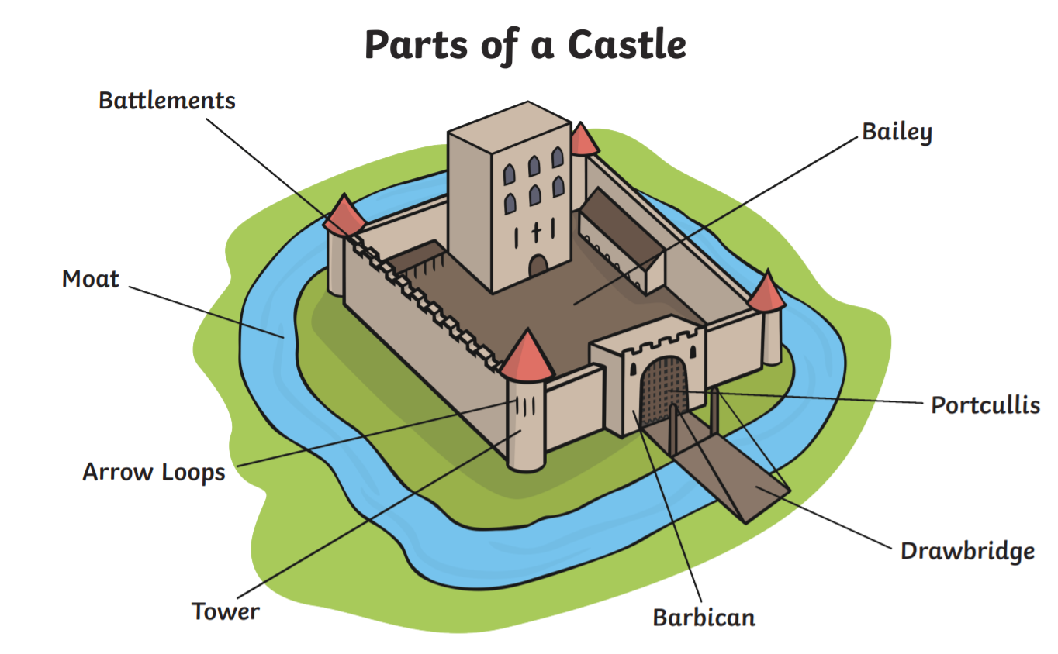

Can your child name the different parts of a castle?
Can your child tell you what a drawbridge is for?

Reminders:
Class 7 PE day (indoor and outdoor) is Thursday.
Class 8 PE days are Wednesday (outdoors) and Thursday (indoors).
Class 7 PE day (indoor and outdoor) is Thursday.

Children need a t-shirt, shorts (for indoor PE), long trousers (for outdoor PE), trainers and a jumper in their PE bags.

Attendance for KS1:
Class 7 – 100%
Class 8 – 97.2%
Class 9 – 98.2%
Homework
Homework will mainly be handed out on a Tuesday. On the odd occasion it may be on a different day due to timetable changes. Please return homework on a Monday. Handing it on a Monday gives you the opportunity before the weekend to ask the teacher any questions so that you are clear of how to support your child if unsure. There is a tray in each class where the homework needs to be returned. Please ask the teacher where this tray is if unsure.

Spellings
Spellings are handed out each Thursday and your child will be tested on these spellings the following Thursday. Children will receive a list of spellings to practise each week. In addition to the spellings, children will be tested on a sentence containing the words. However, the sentence will not be sent home. This is to see if they can apply the spelling currently within their writing. Can you get your child to practise applying the words by creating their very own sentences?

Reading Diaries
Children in KS1 have all been provided with a Home Reading Diary. Please fill this in daily based on your child reading a couple of pages of a book or a whole book. Please return the Reading Diary to school each day and leave it in their book bags. There are books situated in the classroom for your child to take home daily. Reading is extremely important to your child’s development so we really encourage your child to read a book or pages of a book daily. If you are unsure of your child’s reading book colour then please ask your teacher.

Online Safety
The Education for a Connected World framework is used by Royd Nursery Infant School to support in the delivery of online safety. It is a tool for anyone who works with children and young people. It enables the development of teaching and learning as well as guidance to support children and young people to live knowledgeably, responsibly and safely in a digital world.

It focuses specifically on eight different aspects of online education. Strand 7 focuses on “Privacy and security”
To view Strand 7 “Privacy and security” please click on the following link and scroll to page 36 and 37 (if you would like to know more about this strand and what is covered from ages 7 – 18 please scroll to pages 38 – 41): https://assets.publishing.service.gov.uk/media/5efa05b4e90e075c5492d58c/UKCIS_Education_for_a_Connected_World_.pdf

Thank you
Miss Payne, Miss Howes & Miss Aldam

