
Weekly Newsletter
W.B. 11.11.24

This week:
As part of English this week the children have continued their poetry genre, focusing on the poem ‘I am a colossal house”. This week, the children have learnt about completing a cloze. A cloze consists of a portion of text with certain words missing. The children had to complete the cloze by adding in the missing words. Later in the week, the children looked at planning their own poem. They thought carefully of different vocabulary to include in their writing and changing the theme from a house to a castle. The children then neatly wrote their final poem up in their books. They have been so creative and remembered to use stanzas and correct punctuation!

Can your child tell you the features of a poem? Can they perform their poem to you from memory? Can you guess the theme of their poem?

As part of Maths the children have been learning to count in 10’s forwards and backwards. The children know that when we count in
10’s the numbers end in a 0.

Can your child complete the counting sequences below by filling in the missing numbers? Remember to check whether the sequences are counting forwards or backwards first!

30, 40, ____, 60, 70, ___, ___
100, ___, 80, 70, ___, ____, 40

The children’s topic this half term is ‘Towers, Tunnels and Turrets’. The children thoroughly enjoyed our trip to Warwick Castle this week where they could experience a life in a castle first-hand.
We climbed up some spiral steps to get a better view of the bailey, tower and arrow loops that protected the soldiers from their enemies. We found out about the armour that was worn by soldiers and horses in battle. We also went into the grand bedrooms to see how the king and his family lived. The children loved to see the features of a castle in real life!
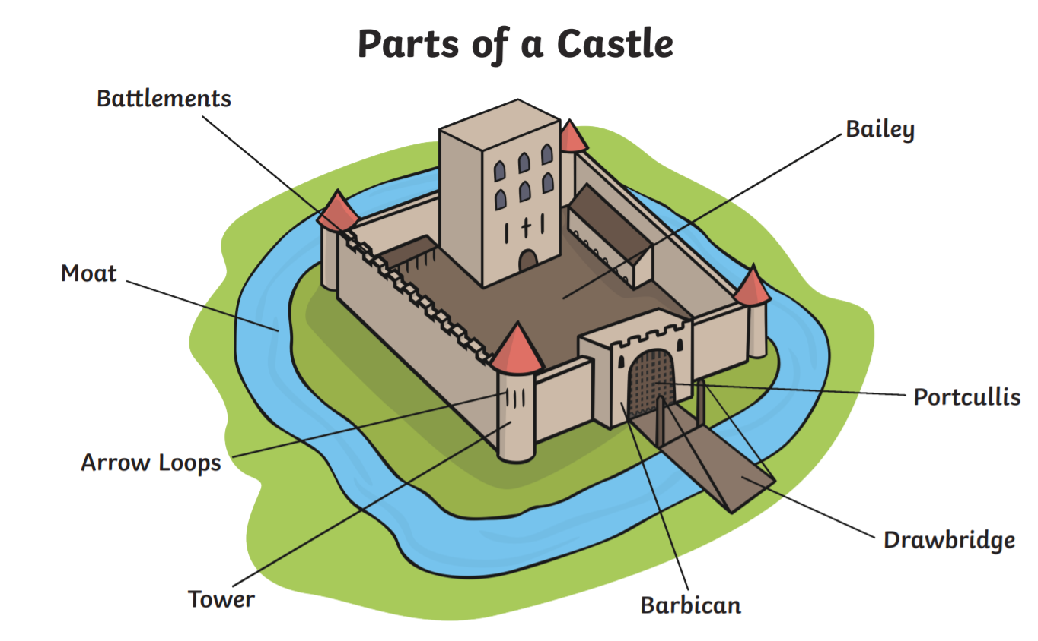

Can your child name the different parts of a castle?
Can your child tell you what a drawbridge is for?

Reminders:
Class 7 PE day (indoor and outdoor) is Thursday.
Class 8 PE days are Wednesday (outdoors) and Thursday (indoors).
Class 7 PE day (indoor and outdoor) is Thursday.

Children need a t-shirt, shorts (for indoor PE), long trousers (for outdoor PE), trainers and a jumper in their PE bags.

Attendance for KS1:
Class 7 – 94.6%
Class 8 – 98.3%
Class 9 – 97.5%
Homework
Homework will mainly be handed out on a Tuesday. On the odd occasion it may be on a different day due to timetable changes. Please return homework on a Monday. Handing it on a Monday gives you the opportunity before the weekend to ask the teacher any questions so that you are clear of how to support your child if unsure. There is a tray in each class where the homework needs to be returned. Please ask the teacher where this tray is if unsure.

Spellings
Spellings are handed out each Thursday and your child will be tested on these spellings the following Thursday. Children will receive a list of spellings to practise each week. In addition to the spellings, children will be tested on a sentence containing the words. However, the sentence will not be sent home. This is to see if they can apply the spelling currently within their writing. Can you get your child to practise applying the words by creating their very own sentences?

Reading Diaries
Children in KS1 have all been provided with a Home Reading Diary. Please fill this in daily based on your child reading a couple of pages of a book or a whole book. Please return the Reading Diary to school each day and leave it in their book bags. There are books situated in the classroom for your child to take home daily. Reading is extremely important to your child’s development so we really encourage your child to read a book or pages of a book daily. If you are unsure of your child’s reading book colour then please ask your teacher.

Online Safety
The Education for a Connected World framework is used by Royd Nursery Infant School to support in the delivery of online safety. It is a tool for anyone who works with children and young people. It enables the development of teaching and learning as well as guidance to support children and young people to live knowledgeably, responsibly and safely in a digital world.

It focuses specifically on eight different aspects of online education. Strand 7 focuses on “Privacy and security”
To view Strand 7 “Privacy and security” please click on the following link and scroll to page 36 and 37 (if you would like to know more about this strand and what is covered from ages 7 – 18 please scroll to pages 38 – 41): https://assets.publishing.service.gov.uk/media/5efa05b4e90e075c5492d58c/UKCIS_Education_for_a_Connected_World_.pdf

Thank you
Miss Payne, Miss Howes & Miss Aldam

