
Weekly Newsletter
W.B. 4.11.24

As part of English this week we have started our new focus around poetry.
The children have listened to a poem and then have had to perform, analyse and reorder a poem.
The children have looked at the structure and layout of the way a poem is set out, looking carefully at the verses and labelling these features found. When performing the poem, the children have created actions to help them remember the poem and express the language used. The children then performed the poem without the words visible to them. They were fantastic! The children then discussed the poem as a class, thinking about what they liked about the poem and what words they liked. Finally, when ordering the poem, the children had to read the lines given to them and re-order them in the correct sequence so that the poem made sense.

Can your child tell you features of a poem? Can they perform the poem to you from memory? Can they tell you any key words from the poem?

In Maths this week, the children have started their new topic on shape. The children have been naming 2D and 3D shapes and looking at their properties. The children have come across specific vocabulary which they have been focusing on when describing the property of a shape:

Vertices - where two edges come together to make a point or a corner.
Edges - the sides around the EDGE of the shape.
Faces – the flat surfaces of a solid shape.

Can your child name 2D shapes? Can they name 3D shapes?
Can they describe the properties of the shape using the vocabulary above?

The children’s topic this half term is ‘Towers, Tunnels and Turrets’. In History, we have started learning about the different parts of a castle. In our first lesson, we listened to lots of information about castles for example the first castles built were ‘Motte and Bailey’ castles and then stone castles were built because wood was not strong enough. In our second history lesson, we labelled the different parts of a castle such as a moat around the castle or a portcullis to prevent enemies from entering or leaving the castle.

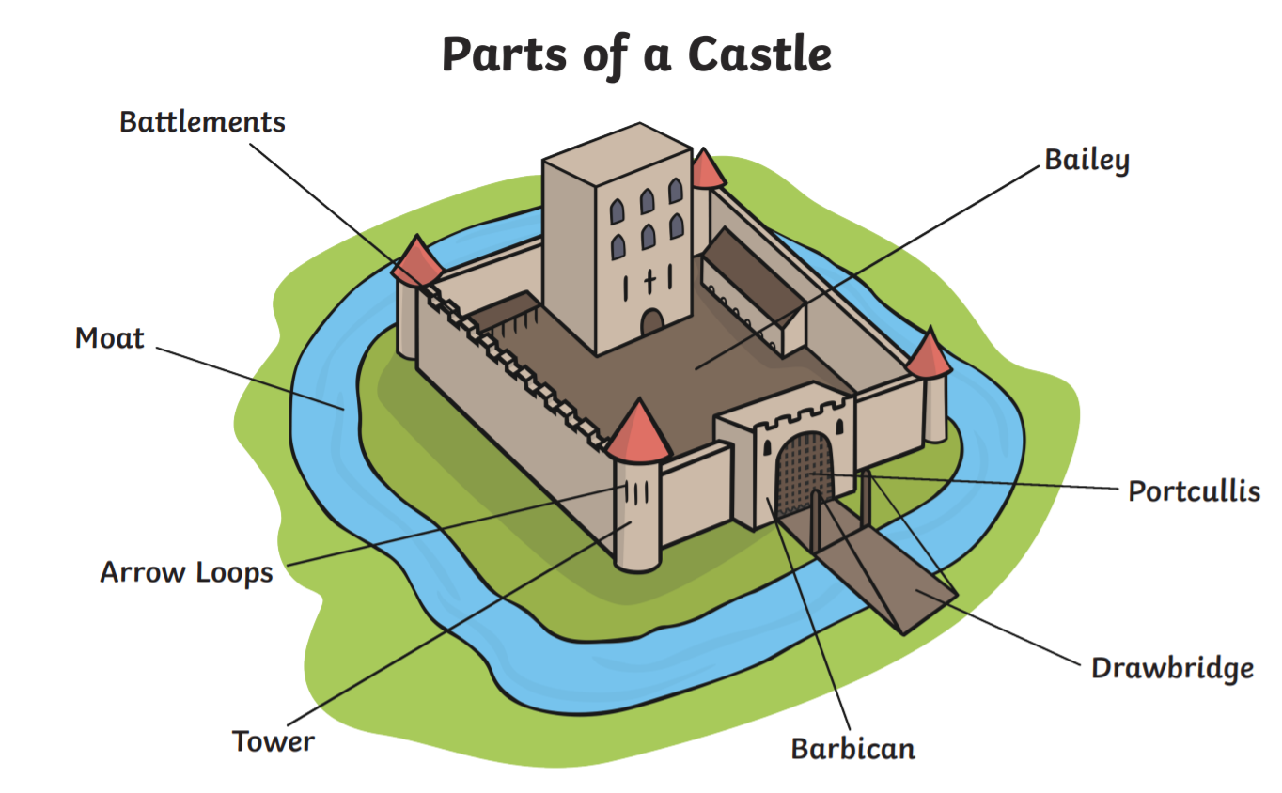

Can your child name the different parts of a castle?
Can your child tell you what a drawbridge is for?

Reminders:
All Year 1 children are doing PE on Thursdays. Children need a t-shirt, shorts (for indoor PE), long trousers (for outdoor PE), trainers and a jumper in their PE bags.
Year 2 children are swimming on Thursdays.

Attendance for KS1:
Class 7 – 94.6%
Class 8 – 98.3%
Class 9 – 97.5%

Homework
Homework will mainly be handed out on a Tuesday. On the odd occasion it may be on a different day due to timetable changes. Please return homework on a Monday. Handing it on a Monday gives you the opportunity before the weekend to ask the teacher any questions so that you are clear of how to support your child if unsure. There is a tray in each class where the homework needs to be returned. Please ask the teacher where this tray is if unsure.

Spellings
Spellings are handed out each Thursday and your child will be tested on these spellings the following Thursday. Children will receive a list of spellings to practise each week. In addition to the spellings, children will be tested on a sentence containing the words. However, the sentence will not be sent home. This is to see if they can apply the spelling currently within their writing. Can you get your child to practise applying the words by creating their very own sentences?

Reading Diaries
Children in KS1 have all been provided with a Home Reading Diary. Please fill this in daily based on your child reading a couple of pages of a book or a whole book. Please return the Reading Diary to school each day and leave it in their book bags. There are books situated in the classroom for your child to take home daily. Reading is extremely important to your child’s development so we really encourage your child to read a book or pages of a book daily. If you are unsure of your child’s reading book colour then please ask your teacher.

Online Safety
The Education for a Connected World framework is used by Royd Nursery Infant School to support in the delivery of online safety. It is a tool for anyone who works with children and young people. It enables the development of teaching and learning as well as guidance to support children and young people to live knowledgeably, responsibly and safely in a digital world.

It focuses specifically on eight different aspects of online education. Strand 6 focuses on “Health, well-being and lifestyle”

To view Strand 6 “Health, well-being and lifestyle” please click on the following link and scroll to page 31 and 32 (if you would like to know more about this strand and what is covered from ages 7 – 18 please scroll to pages 33 – 35):
https://assets.publishing.service.gov.uk/media/5efa05b4e90e075c5492d58c/UKCIS_Education_for_a_Connected_World_.pdf
Thank you
Miss Payne, Miss Howes & Miss Aldam

