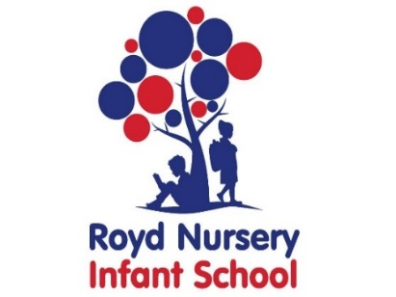

Royd Nursery Infant School

Carr Road, Deepcar

Sheffield, S36 2PR

Tel 0114 288 2594

Email [enquiries@royd.sheffield.sch.uk](mailto:enquiries@royd.sheffield.sch.uk)

[www.roydnurseryinfants.co.uk](http://www.roydnurseryinfants.co.uk)

Headteacher: Louise Jones

19 November 2024

Dear Parents/Carers,

On Thursday 19 December 2024 after school there is a Christmas party for the Reception children.

Children will be participating in activities that will be Christmas related including playing traditional games (eg musical statues), watching a short Christmas related movie and having their party food. The party finishes at 4.20 pm and the collection of your child is from their normal classroom door.

If you would like your child to attend the cost is £5. Payment and consent is to be made via Parentpay. If your child has dietary requirements these must be stated in the notes section. Monies need to be received by 2pm Friday 6 December 2024 so that all supplies and food can be purchased in time for the party.

Thank you.

Yours sincerely,

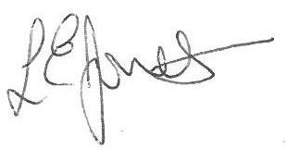

Louise Jones Sean Sly

Executive Head Acting Deputy Head





