



4 November 2024

Dear Parents / Carers,

On Friday 15th November, we are helping to raise funds for the fantastic cause ‘Children in Need’.



Pupils may wear Pudsey merchandise or PJ’s on the day with a minimum donation of £1 that will be collected on Parentpay.

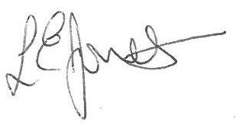Yours sincerely,

Louise Jones

Executive Headteacher

