
Weekly Newsletter
W.B. 7.10.24

This week:
As part of English this week the children have continued their first story writing genre of the year with Little Red Riding Hood. We have focused on suffixes and looked at adding the suffix ‘ly’ which changes an adjective in to an adverb (e.g. nice -> nicely). We then looked at the suffix ‘ed’ which makes words past tense, meaning something has already happened. After that, the children learnt about the suffix ‘er’ which is used to compare things (comparative suffix) and the suffix ‘est’ which is used to compare two or more things (superlative suffix), both of which share the same spelling rules. Finally, we looked at the suffix ‘ful’ which makes words full of something (e.g. beautiful is full of beauty) and ‘ness’ which means the state, condition or quality of something (e.g. redness is the quality of being red).
Take a look at the spelling rules for each of the suffixes your child has learnt this week below:
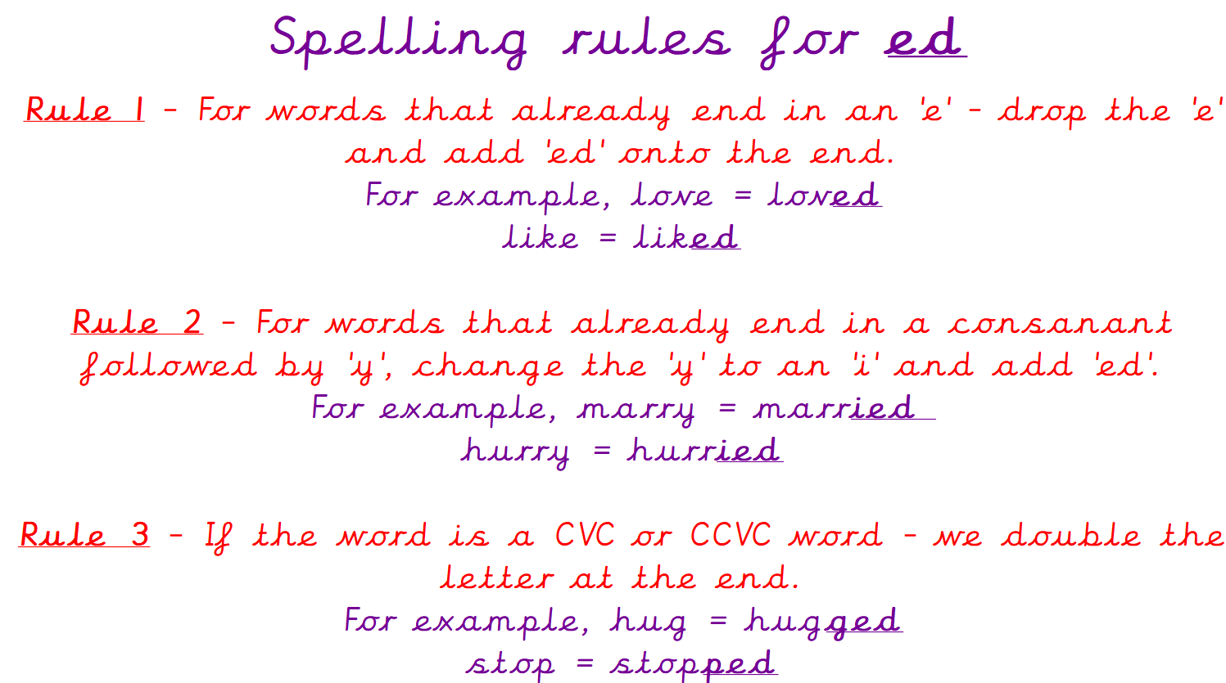
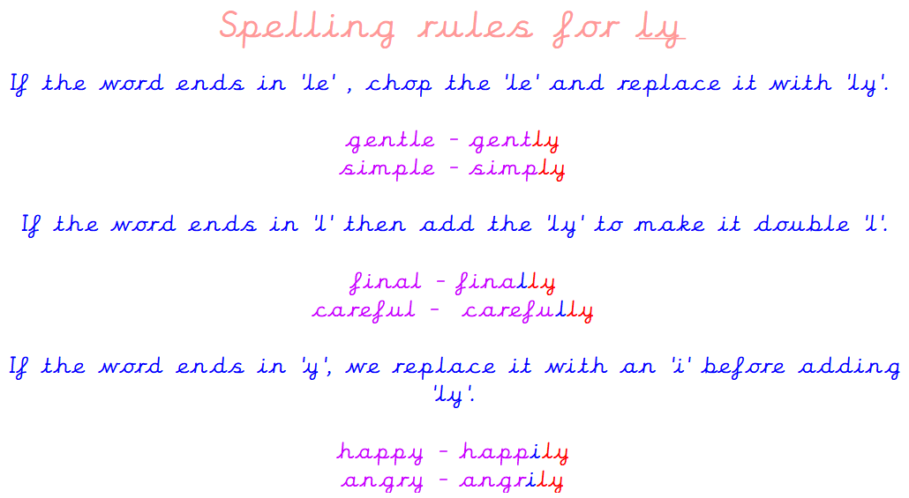
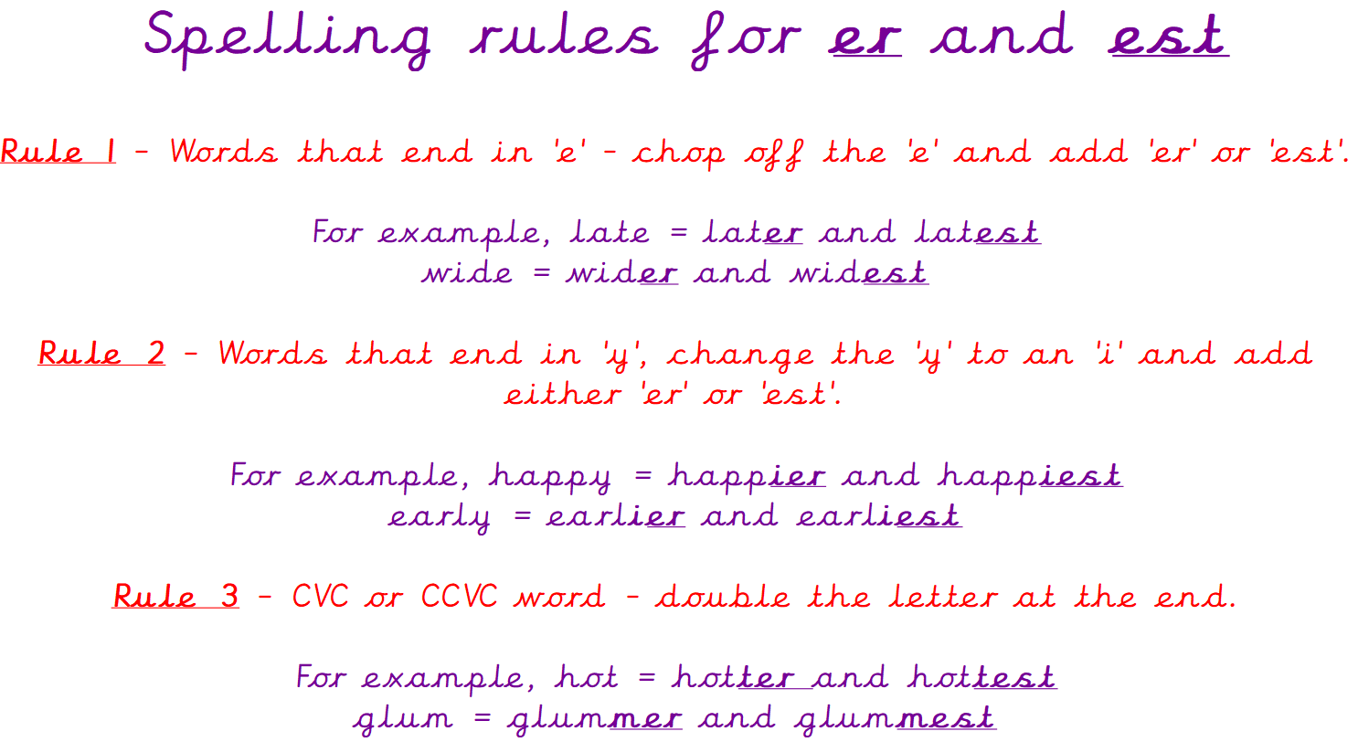
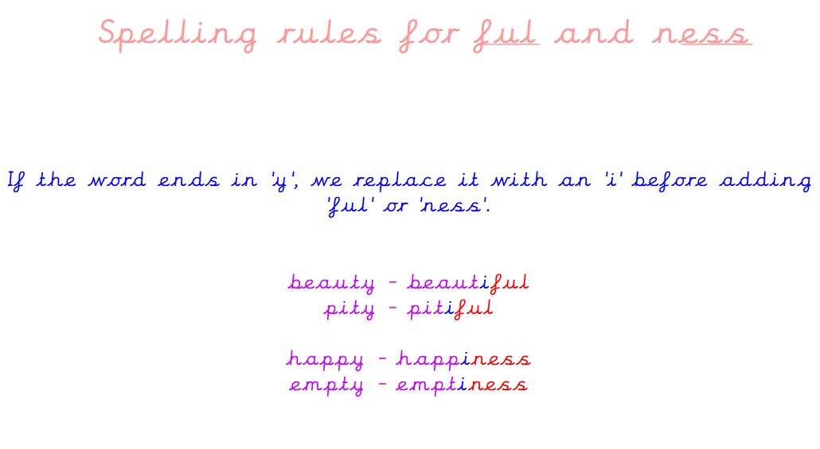

Can your child tell you the spelling rules for adding these suffixes?
Can they add the suffixes to root words?
Can they write a sentence using those words?

As part of Maths the children have continued their first area of focus: Place Value. children have continued to look at number lines and paying particular attention to the start and end number. The children have recognised what the number line is counting in (either 1s, 2s, 3s, 5s, or 10s) and they have identified whether it is counting forwards or backwards. With this knowledge, the children then completed the number lines by filling in the missing numbers. Can your child complete the following number lines:

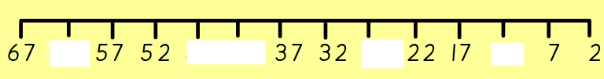
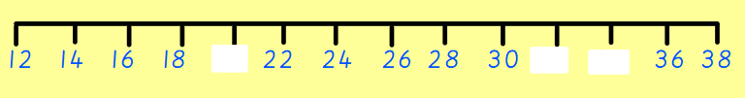

The children’s topic this half term is ‘Muck, Mess and Mixtures’. As part of topic lessons, children have continued their Science learning. We have been looking at different materials (metal, wood, plastic, glass, fabric, rock) and their properties e.g. soft, hard, smooth, transparent, shiny, dull rough and smooth. The children have explored touching a range of objects made from different materials before correctly sorting them into the correct material e.g. fork = metal

Can your child tell you the properties of wood? (hard, rigid)
Can your child tell you the properties of glass? (often transparent or translucent, brittle)

Reminders:
All Year 1 children are doing PE on Thursdays. Children need a t-shirt, shorts (for indoor PE), long trousers (for outdoor PE), trainers and a jumper in their PE bags.
Year 2 children are swimming on Thursdays.

Attendance for KS1:
Class 7 – 93.8%
Class 8 – 94.6%
Class 9 – 97.2%

Homework
Homework will mainly be handed out on a Tuesday. On the odd occasion it may be on a different day due to timetable changes. Please return homework on a Monday. Handing it on a Monday gives you the opportunity before the weekend to ask the teacher any questions so that you are clear of how to support your child if unsure. There is a tray in each class where the homework needs to be returned. Please ask the teacher where this tray is if unsure.

Spellings
Spellings are handed out each Thursday and your child will be tested on these spellings the following Thursday. Children will receive a list of spellings to practise each week. In addition to the spellings, children will be tested on a sentence containing the words. However, the sentence will not be sent home. This is to see if they can apply the spelling currently within their writing. Can you get your child to practise applying the words by creating their very own sentences?

Reading Diaries
Children in KS1 have all been provided with a Home Reading Diary. Please fill this in daily based on your child reading a couple of pages of a book or a whole book. Please return the Reading Diary to school each day and leave it in their book bags. There are books situated in the classroom for your child to take home daily. Reading is extremely important to your child’s development so we really encourage your child to read a book or pages of a book daily. If you are unsure of your child’s reading book colour then please ask your teacher.

Online Safety
The Education for a Connected World framework is used by Royd Nursery Infant School to support in the delivery of online safety. It is a tool for anyone who works with children and young people. It enables the development of teaching and learning as well as guidance to support children and young people to live knowledgeably, responsibly and safely in a digital world.

It focuses specifically on eight different aspects of online education. Strand 3 focuses on “Online reputation”.

To view Strand 3 “Online reputation” please click on the following link and scroll to page 15 and 16 (if you would like to know more about this strand and what is covered from ages 7 – 18 please scroll to pages 17 – 19):
https://assets.publishing.service.gov.uk/media/5efa05b4e90e075c5492d58c/UKCIS_Education_for_a_Connected_World_.pdf

Thank you
Miss Payne, Miss Howes & Miss Aldam

