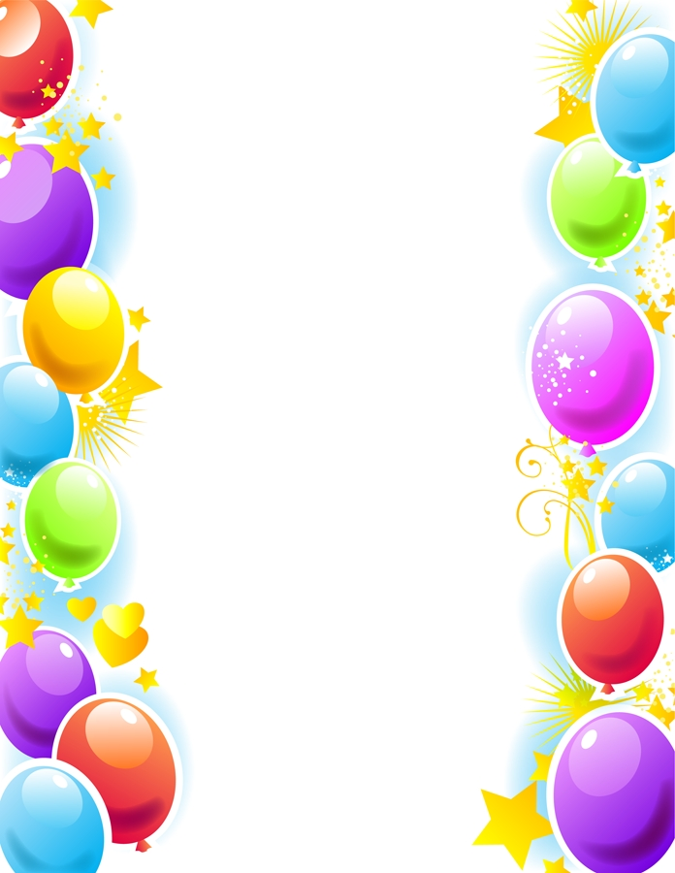
Weekly Newsletter
W.B. 30.9.24

This week:
As part of English this week the children have continued their first story writing genre of the year; Goldilocks and The Three Bears.
We have focused on writing different types of sentences including questions and exclamation sentences. A question is when we want a response or an answer from someone and we always end it with a question mark ‘?’ We came up with a range of question words we can use to start a question when we are writing including; who, what, where, why, when, how, do, which, can, is, are, were. Whenever we are writing an exclamation sentence it must include strong feeling or emotion and end with an exclamation mark ‘!’ For example, “Get out of my house immediately!” yelled Daddy Bear.

Can your child think of a question they would like to ask Goldilocks or The Three Bears? Can your child tell you when an exclamation mark would be used and give an example?

As part of Maths the children have been ordering groups of numbers given from smallest to largest and then form largest to smallest up to 100.

Can your child order the following numbers from smallest to largest and then from largest to smallest?

21 57 34

Remember to look at the tens first and then the ones!

The children’s topic this half term is ‘Muck, Mess and Mixtures’. As part of topic lessons children have continued with their Science learning. They had to explain why certain objects are made out of specific materials e.g. a chair is made out of wood because it is strong and rigid. Gloves are made out of wool because wool is soft and it keeps our hands warm!

Can your child tell you why a water bottle is made out of plastic and not paper?
Can your child tell you why a wall is made out of rock and not fabric?

Reminders:
All Year 1 children are doing PE on Thursdays. Children need a t-shirt, shorts (for indoor PE), long trousers (for outdoor PE), trainers and a jumper in their PE bags.
Year 2 children are swimming on Thursdays.

Attendance for KS1:
Class 7 – 90.3%
Class 8 – 88%
Class 9 - 94.8%

Homework
Homework will mainly be handed out on a Tuesday. On the odd occasion it may be on a different day due to timetable changes. Please return homework on a Monday. Handing it on a Monday gives you the opportunity before the weekend to ask the teacher any questions so that you are clear of how to support your child if unsure. There is a tray in each class where the homework needs to be returned. Please ask the teacher where this tray is if unsure.

Spellings
Spellings are handed out each Thursday and your child will be tested on these spellings the following Thursday. Children will receive a list of spellings to practise each week. In addition to the spellings, children will be tested on a sentence containing the words. However, the sentence will not be sent home. This is to see if they can apply the spelling currently within their writing. Can you get your child to practise applying the words by creating their very own sentences?

Reading Diaries
Children in KS1 have all been provided with a Home Reading Diary. Please fill this in daily based on your child reading a couple of pages of a book or a whole book. Please return the Reading Diary to school each day and leave it in their book bags. There are books situated in the classroom for your child to take home daily. Reading is extremely important to your child’s development so we really encourage your child to read a book or pages of a book daily. If you are unsure of your child’s reading book colour then please ask your teacher.

Online Safety
The Education for a Connected World framework is used by Royd Nursery Infant School to support in the delivery of online safety. It is a tool for anyone who works with children and young people. It enables the development of teaching and learning as well as guidance to support children and young people to live knowledgeably, responsibly and safely in a digital world.

It focuses specifically on eight different aspects of online education. Strand 2 focuses on “Online relationships”
To view Strand 2 “Online relationships” please click on the following link and scroll to page 10 and 11 (if you would like to know more about this strand and what is covered from ages 7 – 18 please scroll to pages 12 – 14): https://assets.publishing.service.gov.uk/media/5efa05b4e90e075c5492d58c/UKCIS_Education_for_a_Connected_World_.pdf

Thank you
Miss Payne, Miss Howes & Miss Aldam

