
Weekly Newsletter
W.B. 16.9.24

This week:
As part of English this week the children have continued their first story writing genre of the year; Goldilocks and The Three Bears. We looked at describing the characters and the setting within the story.
Following on from this the children generated some ambitious vocabulary for adjectives (a word that describes a noun) and verbs (doing or being words) by using some of the words from the story e.g. shiny = glimmering.

Can your child explain what a noun is? (Person, place or thing). Can your child describe what an adjective is? (A word to describe a noun). Can your child explain what a verb is? (A doing word – jumping, knitting, went).

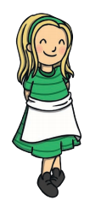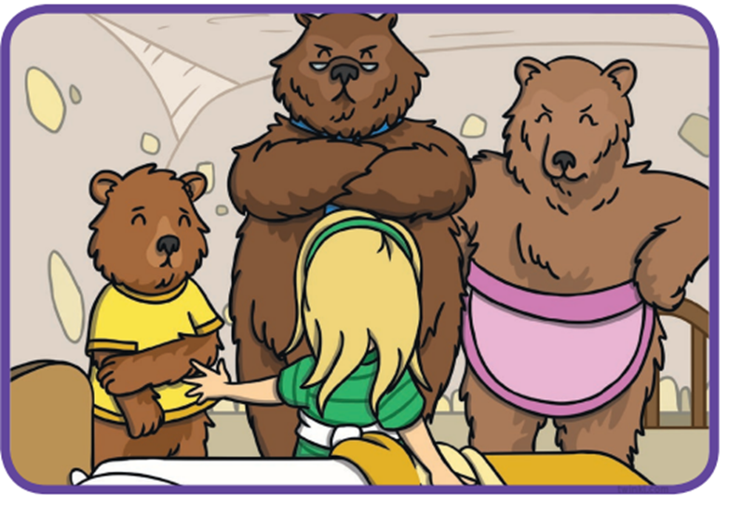

As part of Maths the children have been looking at the most and least in amounts of objects. Children had to count the items in the pictures, compare the amounts and identify which image had the most or the least. They then progressed onto looking at equal amounts and the children had to count and identify which two pictures had the same amount of objects or which was equal to a number provided.

At home please can you support your child with counting the amounts of objects and comparing which has the most and the least or equal amounts.

The children’s topic this half term is ‘Muck, Mess and Mixtures’. As part of topic lessons children have continued completing art-based activities. They have used their artistic skills to paint an image of a test tube using one of the three primary colours. Can your child name the three primary colours?
The children then evaluated their paintings by selecting what they like and what they dislike, whilst reflecting on what they would improve in the future.

Reminders:
All Year 1 children are doing PE on Thursdays. Children need a t-shirt, shorts (for indoor PE), long trousers (for outdoor PE), trainers and a jumper in their PE bags.
Year 2 children are swimming on Thursdays.

Attendance for KS1:
Class 7 – 94%
Class 8 – 96.3%
Class 9 – 90.6%

Homework
Homework will mainly be handed out on a Tuesday. On the odd occasion it may be on a different day due to timetable changes. Please return homework on a Monday. Handing it on a Monday gives you the opportunity before the weekend to ask the teacher any questions so that you are clear of how to support your child if unsure. There is a tray in each class where the homework needs to be returned. Please ask the teacher where this tray is if unsure.

Spellings
Spellings are handed out each Thursday and your child will be tested on these spellings the following Thursday. Children will receive a list of spellings to practise each week. In addition to the spellings, children will be tested on a sentence containing the words. However, the sentence will not be sent home. This is to see if they can apply the spelling currently within their writing. Can you get your child to practise applying the words by creating their very own sentences?

Reading Diaries
Children in KS1 have all been provided with a Home Reading Diary. Please fill this in daily based on your child reading a couple of pages of a book or a whole book. Please return the Reading Diary to school each day and leave it in their book bags. There are books situated in the classroom for your child to take home daily. Reading is extremely important to your child’s development so we really encourage your child to read a book or pages of a book daily. If you are unsure of your child’s reading book colour then please ask your teacher.

Online Safety
The Education for a Connected World framework is used by Royd Nursery Infant School to support in the delivery of online safety. It is a tool for anyone who works with children and young people. It enables the development of teaching and learning as well as guidance to support children and young people to live knowledgeably, responsibly and safely in a digital world.
It focuses specifically on eight different aspects of online education:
1. Self-image and Identity
2. Online relationships
3. Online reputation
4. Online bullying
5. Managing online information
6. Health, wellbeing and lifestyle
7. Privacy and security
8. Copyright and ownership
To view the document please click on the following link: https://assets.publishing.service.gov.uk/media/5efa05b4e90e075c5492d58c/UKCIS_Education_for_a_Connected_World_.pdf

Thank you
Miss Aldam, Miss Howes & Miss Payne

