

Royd Nursery Infant School

Carr Road, Deepcar

Sheffield, S36 2PR

Tel 0114 288 2594

Email [enquiries@royd.sheffield.sch.uk](mailto:enquiries@royd.sheffield.sch.uk)

[www.roydnurseryinfants.co.uk](http://www.roydnurseryinfants.co.uk)

Headteacher: Louise Jones

17 October 2024

Dear Parents/Carers

For children in FS2, Y1 and Y2 we are running several extra curricular activities during the Autumn 2 half term.

Dance remains on a Monday and Friday is now Dodgeball. For our Reception families, please note that Football and Choir are for Year 1 and 2 children.

For your child to attend, you will need to log on to Parentpay then select and pay for the club/s you wish your child to attend. This will be on a first come first served basis and the places become available later today.

Yours sincerely,

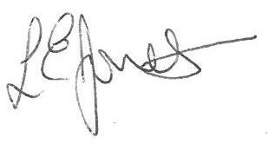

Louise Jones Sean Sly

Executive Head Acting Deputy Head

-------------------------------------------------------------------------------------------------------------------  
**Extra Curricular Activities Autumn 2 2024**

**Monday**

Dance FS2/Y1/Y2 3.20pm – 4.20pm 4 Nov – 16 Dec £31.50

**Tuesday**

Learning new FS2/Y1/Y2 3.20pm – 4.20pm 5 Nov – 17 Dec £31.50

Sports

**Wednesday**

Football Y1//Y2 3.30pm – 4.30pm 6 Nov – 5 Dec 22.50

**Thursday**

Choir Y1/Y2 3.20pm – 4.00 pm 7 Nov – 12 Dec £1

**Friday**

Dodgeball FS2/Y1/Y2 3.20pm – 4.20 pm 8 Nov – 20 Dec £31.50





