2 Year Provision Newsletter
– w/c 08/07/24
Last week
In provision last week we continued doing various activities around our topic “Which is the biggest dinosaur?”. The children have really enjoyed learning about dinosaurs and pretending to be dinosaurs!
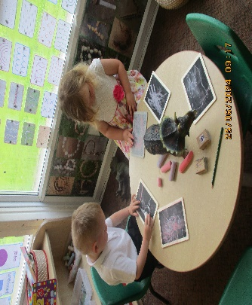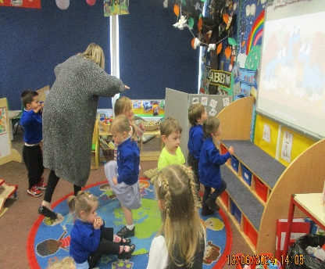

This week  We are continuing our topic “Which is the biggest dinosaur?”.  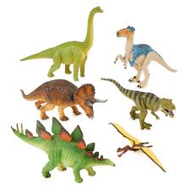  We also beginning to look to the summer so we have a travel agents/airport in our home corner, buckets and spades in the sandpit. | Book of the week  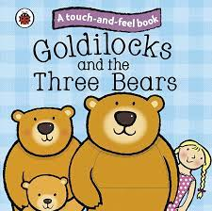  This story is linked to our theme we are running this term.  Maybe if you have this story at home you could look though the story together at bedtime.
Dates for your Diary
Summer Fayre – 16th July 2pm
Last Day – 19th July
We return to school on Wednesday 4th September 2024

Spare Clothes
Thank you for all the donations of spare clothes, we are very grateful!

Reminder
A gentle reminder about only providing water in water bottles. Thank you.

As the weather is now beginning to become a little warmer can you please ensure your child has a labelled sun hat and is wearing sun cream.
Can you also ensure they have their water bottle so they are able to stay well hydrated during the warm weather.

Please remember to ensure all your child’s clothing and water bottles are labelled and if you could provide spare clothes in their bag.
Thank you!

