
Weekly Newsletter
W.B. 8.7.24

Please can we ask that any reading books taken home are returned to your child’s classroom book boxes after they’ve been used.

This week:

This week in our English lessons the children have written their letter to Astronaut Smith, requesting to join his space shuttle. They have remembered to include the steps for success; address of the recipient, address of the sender, date, who you are writing to, introductory paragraph, main information (selling themselves), concluding paragraph and finishing the letter with ‘yours sincerely’.

Can your child tell you what they wrote in their letter to Astronaut Smith?

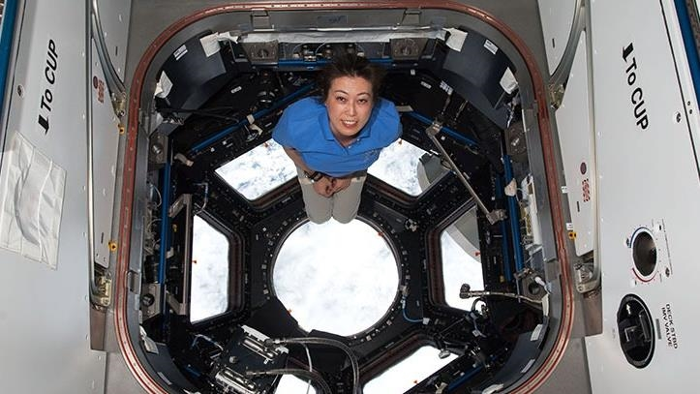

As part of Maths this week the children in year 2 have continued the unit around fractions. They have continued to look at halves, quarters and thirds. Children have had to recognise a fraction of a shape and an amount and have learned that one half is equivalent to two quarters. We have learned to use the correct vocabulary when looking at fractions; denominator and numerator. The children have enjoyed exploring this unit of work and have worked very hard to ensure they can apply their skills to solve word problems and to investigate.

Can your child identify a fraction?
Can they shade a fraction of a shape?
Can they tell you the fraction of an amount?

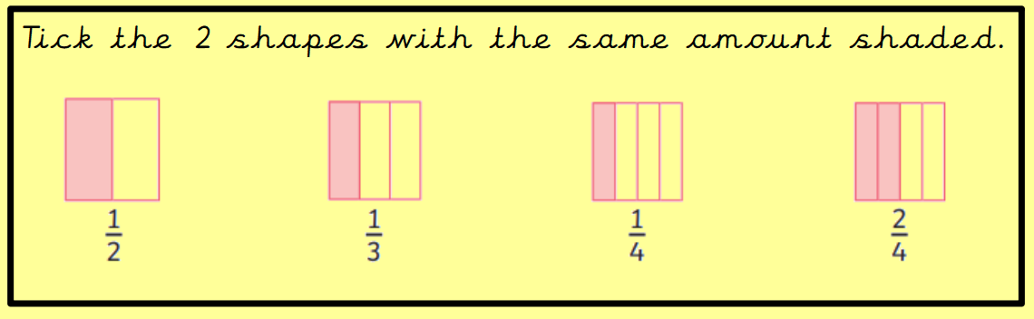
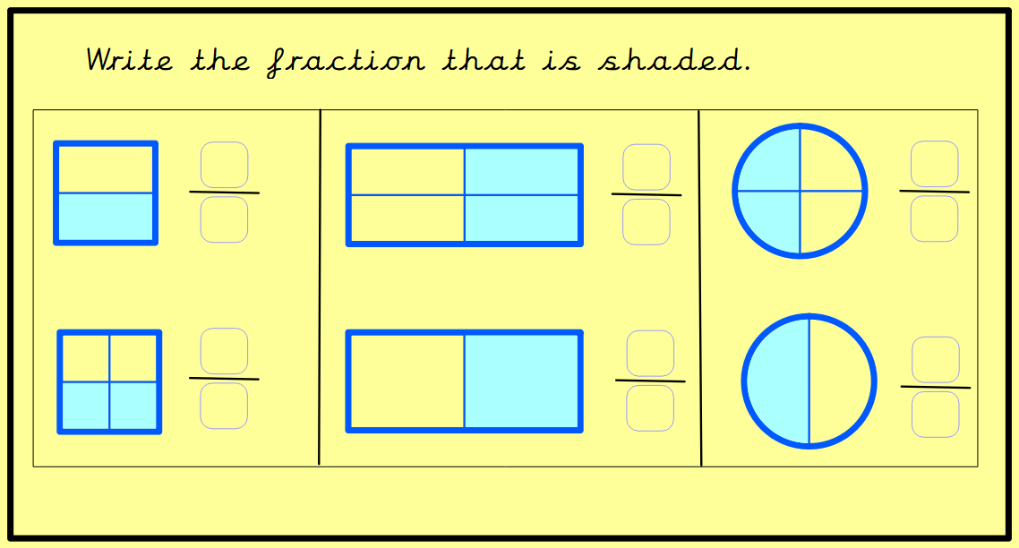

Our topic this half-term is ‘Moon Zoom’. For Geography, we are focusing on data collection. We wanted to find out the number of coloured cars that passed school and if more cars were travelling up the hill or down the hill. We observed this by taking a record outside of school. We took clipboards and pencils and recorded our data using a tally chart. After this, we created a graph on Purple Mash to represent our data findings. We then analysed the data and answered questions about it for example:

Can your child tell you the colour of car that passed school the least?
Can your child tell you the colour of car that passed school the most?
What was the difference between the most popular coloured car and least popular coloured car?

Reminders:

Class 7 PE days are Monday and Tuesday.
Class 8 PE days are Monday and Tuesday.

Attendance for KS1:
Class 7 – 0%
Class 8 – 0%

Homework
Homework will mainly be handed out on a Wednesday. On the odd occasion it may be on a different day due to timetable changes. Please return homework on a Monday. Handing it on a Monday gives you the opportunity before the weekend to ask the teacher any questions so that you are clear of how to support your child if unsure. There is a tray in each class where the homework needs to be returned. Please ask the teacher where this tray is if unsure.

Spellings
Spellings are handed out each Thursday and your child will be tested on these spellings the following Thursday. Children will receive a list of spellings to practise each week. In addition to the spellings, children will be tested on a sentence containing the words. However, the sentence will not be sent home. This is to see if they can apply the spelling currently within their writing. Can you get your child to practise applying the words by creating their very own sentences?
Reading Diaries
Children in KS1 have all been provided with a Home Reading Diary. Please fill this in daily based on your child reading a couple of pages of a book or a whole book. Please return the Reading Diary to school each day and leave it in the designated classroom tray. There are books situated in the classroom for your child to take home daily. Reading is extremely important to your child’s development so we really encourage your child to read a book or pages of a book daily. If you are unsure of your child’s reading book colour then please ask your teacher.

Thank you
Miss Bamford & Miss Payne

