
Weekly Newsletter
W.B. 1.7.24

Please can we ask that any reading books taken home are returned to your child’s classroom book boxes after they’ve been used.

This week:

This week in English the children have started their new topic of a formal letter. The children are going to be writing a letter to Astronaut Smith, requesting to join his space shuttle. The children have analysed the WAGOLL (What A Good One Looks Like) and have unpicked lots of ambitious vocabulary such as: request, permission, opportunity, fascinated and they have also analysed the structure of a letter. They have identified: address of the recipient, address of the sender, date, who you are writing to, introductory paragraph, main information (selling themselves), concluding paragraph and finishing the letter with ‘yours sincerely’. They have also looked at the job roles of an Astronaut (navigating, communicating and cooking) and used these to write sentences using conjunctions.

Can your child write a sentence to explain why they would be good at these roles?



As part of Maths this week, children have been learning about fractions. In Year 1 we focus on halves and quarters of amounts, also looking at 2/4 being the same as 1/2. First, we looked at finding halves and quarters of shapes, before moving onto amounts. To find halves or quarters of an amount, we used dienes. For example, to find one quarter of 8 we shared 8 into 4 groups and then counted the amount in one of the four groups to find our answer.

Can your child cut an apple or pizza into quarters?
Can your child calculate the following?

1/2 of 20
1/4 of 16

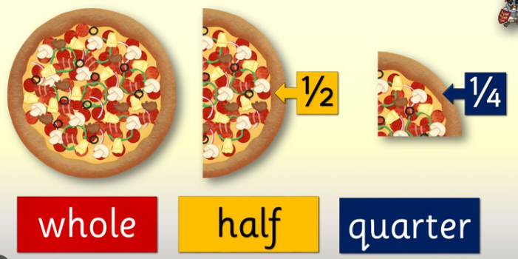

Our topic for this half term is ‘Moon Zoom’. In their Computing slots, Year 1 have been learning about and recording Pictograms on Purple Mash. In Geography, we are also focusing on data collection. We wanted to find out the number of coloured cars that passed school and if more cars were travelling up the hill or down the hill. We observed this by taking a record outside of school. We took clipboards and pencils and recorded our data using a pictogram.

Did more cars travel up the hill or down the hill? Why do you think this is?

Reminders:
Class 8 PE days are Monday and Tuesday.
Class 9 PE days are Monday and Wednesday.

Attendance for KS1:
Class 8 – 90.4%
Class 9 – 94.8%

Homework
Homework will mainly be handed out on a Tuesday. On the odd occasion it may be on a different day due to timetable changes. Please return homework on a Monday. Handing it on a Monday gives you the opportunity before the weekend to ask the teacher any questions so that you are clear of how to support your child if unsure. There is a tray in each class where the homework needs to be returned. Please ask the teacher where this tray is if unsure.

Spellings
Spellings are handed out each Thursday and your child will be tested on these spellings the following Thursday. Children will receive a list of spellings to practise each week. In addition to the spellings, children will be tested on a sentence containing the words. However, the sentence will not be sent home. This is to see if they can apply the spelling currently within their writing. Can you get your child to practise applying the words by creating their very own sentences?

Reading Diaries
Children in KS1 have all been provided with a Home Reading Diary. Please fill this in daily based on your child reading a couple of pages of a book or a whole book. Please return the Reading Diary to school each day and leave it in the designated classroom tray. There are books situated in the classroom for your child to take home daily. Reading is extremely important to your child’s development so we really encourage your child to read a book or pages of a book daily. If you are unsure of your child’s reading book colour then please ask your teacher.

Thank you
Miss Rawding & Miss Payne

