

Royd Nursery Infant School

Carr Road, Deepcar

Sheffield, S36 2PR

Tel 0114 288 2594

Email [enquiries@royd.sheffield.sch.uk](mailto:enquiries@royd.sheffield.sch.uk)

[www.roydnurseryinfants.co.uk](http://www.roydnurseryinfants.co.uk)

Headteacher: Louise Jones

9 July 2024

Dear Parents/Carers

For children in FS2, Y1 and Y2 we are running several extra curricular activities during the Autumn 1 half term.

Dance has moved to a Monday and the ever popular obstacle courses is back. For our new Reception families, please note that Football and Choir are for Year 1 and 2 children.

For your child to attend, you will need to log on to Parentpay then select and pay for the club/s you wish your child to attend. This will be on a first come first served basis and the places become available later this evening.

Yours sincerely,

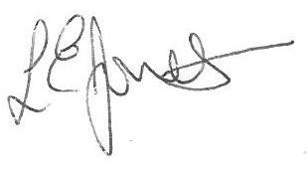

Louise Jones Sean Sly

Executive Head Acting Deputy Head

-------------------------------------------------------------------------------------------------------------------  
**Extra Curricular Activities Summer 2 2024**

**Monday**

Dance FS2/Y1/Y2 3.20pm – 4.20pm 9 Sept – 21 Oct £31.50

**Tuesday**

Learning new FS2/Y1/Y2 3.20pm – 4.20pm 10 Sept – 22 Oct £31.50

Sports

**Wednesday**

Football Y1//Y2 3.30pm – 4.30pm 11 Sept – 23 Oct 31.50

**Thursday**

Choir Y1/Y2 3.20pm – 4.00 pm 12 Sept – 24 Oct £1

**Friday**

Obstacle FS2/Y1/Y2 3.20pm – 4.20 pm 13 Sept – 25 Oct £31.50

Courses





