2 Year Provision Newsletter
– w/c 24/06/24
Last week
In provision last week we did various activities around our topic “Which is the biggest dinosaur?”. The children enjoyed hunting for dinosaur bones in the sand and creating different dinosaur craft using various resources.

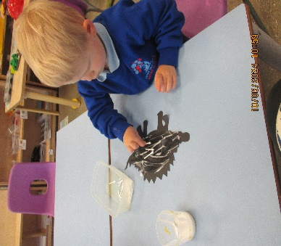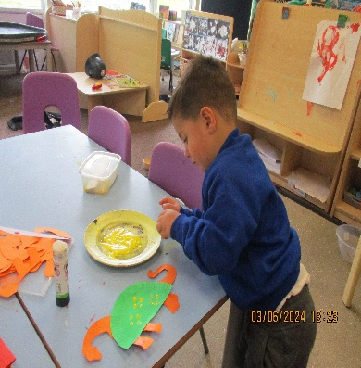

This week  We are continuing our topic “Which is the biggest dinosaur?”.  We have a variety of activities available around this topic such as, which create your own dinosaur with various shapes.  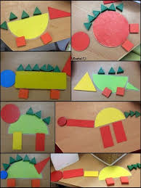 | Book of the week  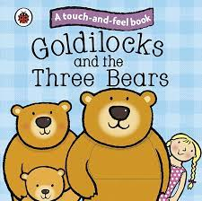  This story is linked to our theme we are running this term.  Maybe if you have this story at home you could look though the story together at bedtime.
Dates for your Diary
Creature Ark – Wednesday 3rd July
Summer Fayre – 16th July 2pm
Last Day – 19th July

Spare Clothes
Thank you for all the donations of spare clothes, we are very grateful!

Reminder
A gentle reminder about only providing water in water bottles. Thank you.

As the weather is now beginning to become a little warmer can you please ensure your child has a labelled sun hat and is wearing sun cream.
Can you also ensure they have their water bottle so they are able to stay well hydrated during the warm weather.

Please remember to ensure all your child’s clothing and water bottles are labelled and if you could provide spare clothes in their bag.
Thank you!

