2 Year Provision Newsletter
– w/c 03/06/24
Last week
Hello, Welcome Back!
We hope you had a lovely half term break and you did lots of fun things!
This week  We are beginning our topic “Which is the biggest dinosaur?”.  We have a variety of activities available around this topic such as, which is the biggest dinosaur and the smallest dinosaur, To finding dinosaur bones in the sand!  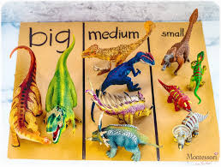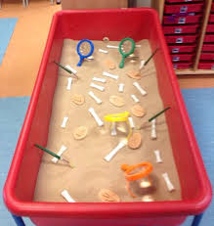 | Book of the week  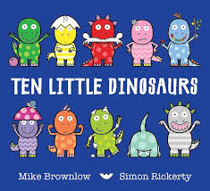  This story is linked to our theme we are running this term.  Maybe if you have this story at home you could look though the story together at bedtime.
Dates for your Diary
Wednesday 6th June – Class photos.
Monday 10th June – Stay and Play 2pm
Wednesday 12th June - Stay and play2pm

Spare Clothes
Thank you for all the donations of spare clothes, we are very grateful!

Reminder
A gentle reminder about only providing water in water bottles. Thank you.

As the weather is now beginning to become a little warmer can you please ensure your child has a labelled sun hat and is wearing sun cream.
Can you also ensure they have their water bottle so they are able to stay well hydrated during the warm weather.

Please remember to ensure all your child’s clothing and water bottles are labelled and if you could provide spare clothes in their bag.
Thank you!

