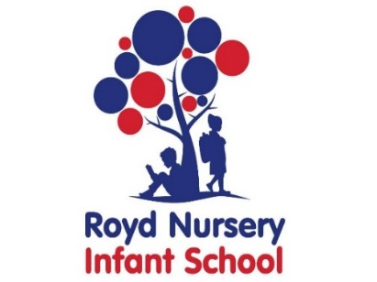

Royd Nursery Infant School

Carr Road, Deepcar

Sheffield, S36 2PR

Tel 0114 288 2594

Email [enquiries@royd.sheffield.sch.uk](mailto:enquiries@royd.sheffield.sch.uk)

[www.roydnurseryinfants.co.uk](http://www.roydnurseryinfants.co.uk)

Headteacher: Louise Jones

12 June 2024

Dear Parents/Carers,

On Thursday 18 July 2024, the Year 2 children and the Choir will be performing at The Venue in Stocksbridge.

The evening will be the Gala Performance of Entertainment to showcase the talent in School and to celebrate our Year 2 children who will be leaving us. Arrival will be from 6.00pm for a prompt 6.30 pm start.

Please ensure that your child is wearing school uniform including a cardigan or sweatshirt.

Tickets are £4.00 each. (Your Year 2 child will not need a ticket as they will be on stage). If you would like to join us please purchase ticket(s) via Parentpay.

Thank you.

Yours sincerely,

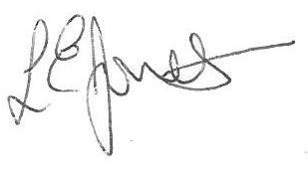

Louise Jones Sean Sly

Executive Head Acting Deputy Head





