
Weekly Newsletter
W.B. 20.5.24

Please can we ask that any reading books taken home are returned to your child’s classroom book boxes after they’ve been used.

This week:

This week in our English writing slots children have used their research to write their information text about the four seasons; Spring, Summer, Autumn and Winter. They did a brilliant job at including the steps for success such as heading, subheading and technical words to do with the subject.

Can your child tell you a fact about each season?



As part of Maths, we have started our multiplication and division unit. We are beginning with multiplication and this week have been focusing on multiplying by 2, 5 and 10 using Numicon boards and pegs.

The children know that when we multiply by 2 we have to count in 2s to find the answer. For example,
3 X 2 = you have to count in 2s three times to find the answer to 3 lots of 2.

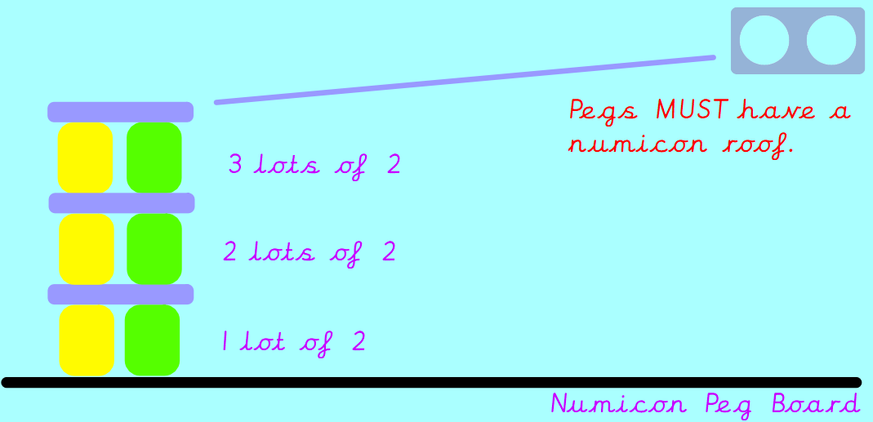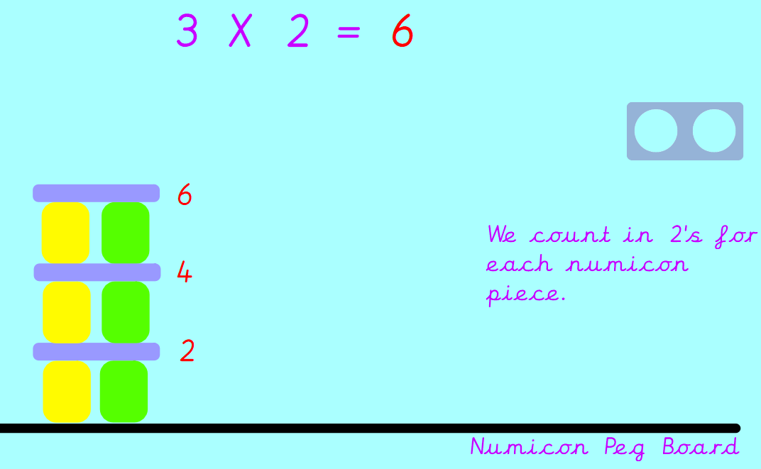

We then started to look at our 5 times tables and 10 times tables using the same method.

Can your child solve the following?
8 X 2 =
3 X 5 =
6 X 10 =

Our topic for this half term is ‘Enchanted Woodland’. As part of topic lessons, the children have finished off their science learning. We observed the growth of our broad bean over time by identifying the changes each week. We then recorded our results in a table and graph before writing about what a plant needs to survive; light, heat and water.

Can your child tell you the changes they observed in their class plant overtime?

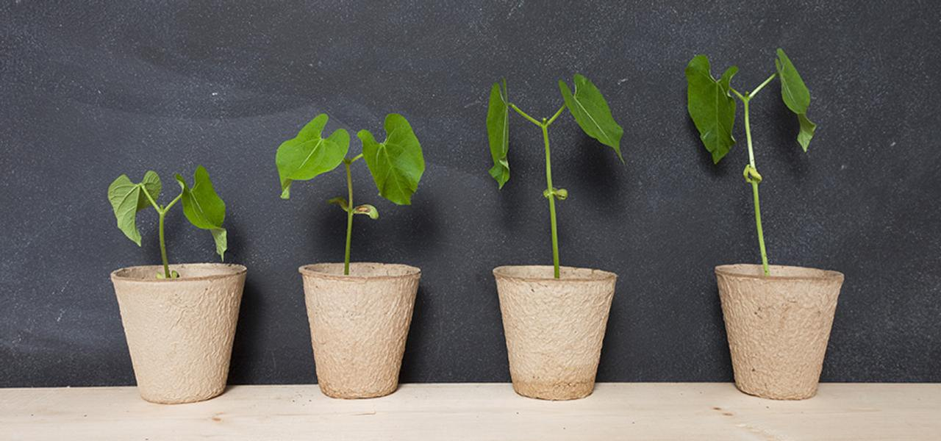

Reminders:
Class 8 PE days are Monday and Tuesday.
Class 9 PE days are Monday and Wednesday.

Attendance for KS1:
Class 8 – 97.8%
Class 9 – 90.7%

Homework
Homework will mainly be handed out on a Tuesday. On the odd occasion it may be on a different day due to timetable changes. Please return homework on a Monday. Handing it on a Monday gives you the opportunity before the weekend to ask the teacher any questions so that you are clear of how to support your child if unsure. There is a tray in each class where the homework needs to be returned. Please ask the teacher where this tray is if unsure.

Spellings
Spellings are handed out each Thursday and your child will be tested on these spellings the following Thursday. Children will receive a list of spellings to practise each week. In addition to the spellings, children will be tested on a sentence containing the words. However, the sentence will not be sent home. This is to see if they can apply the spelling currently within their writing. Can you get your child to practise applying the words by creating their very own sentences?

Reading Diaries
Children in KS1 have all been provided with a Home Reading Diary. Please fill this in daily based on your child reading a couple of pages of a book or a whole book. Please return the Reading Diary to school each day and leave it in the designated classroom tray. There are books situated in the classroom for your child to take home daily. Reading is extremely important to your child’s development so we really encourage your child to read a book or pages of a book daily. If you are unsure of your child’s reading book colour then please ask your teacher.

Thank you
Miss Rawding & Miss Payne

