
Weekly Newsletter
W.B. 3.6.24

Please can we ask that any reading books taken home are returned to your child’s classroom book boxes after they’ve been used.

NOTE: There will be no spelling test taking place (as part of Phonics lessons) the weeks commencing 17th June and 24th June due to School Trips and the transition days.

This week:

This week in our English the children have started their poetry focus. We started off by reading a poem and learning it.

We created actions for the poem to help us remember it. We then moved onto analysing the poem; identifying the steps for success including, lines, stanzas and changing the theme.

Following this, we looked at pictures of planets and space related pictures and described them, thinking about the colour, texture and what it might feel like to be on one of them.

After this, we used our knowledge of stanzas and order of the poem to reorder it by choosing which line comes first and which might come next.

As part of Maths, we have continued their unit of multiplication and division. Instead of using the Numicon boards and pegs, this week the children have been using arrays.

Children have used the arrays to work out and solve calculations for the 2, 5 and 10 times tables. They had to work carefully to draw the correct number of dots and the correct amount of groups for example 5 X 2 (5 lots of 2), meaning they had to draw 5 rows of 2 dots to represent the calculation.

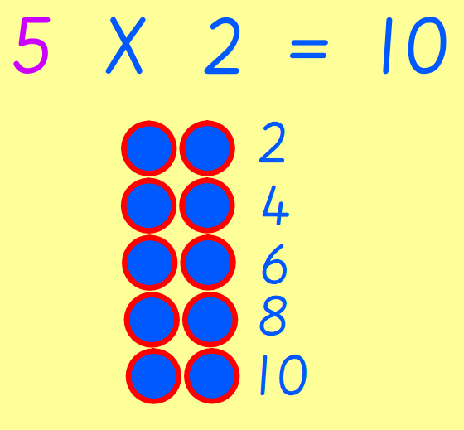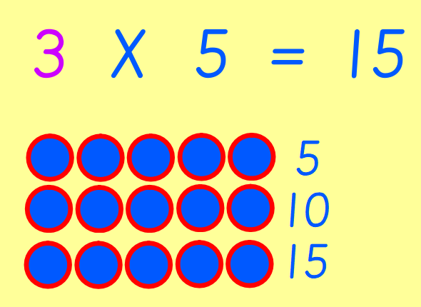

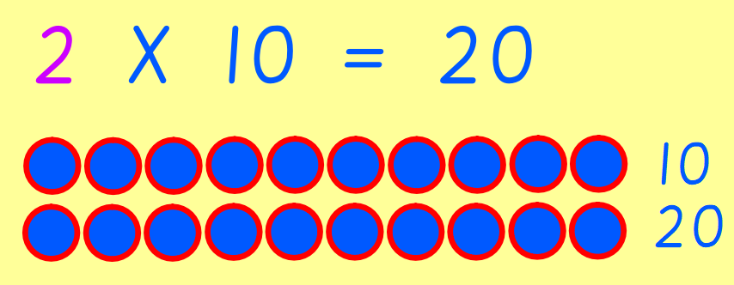
Can your child solve the following by drawing arrays?
9 X 2 =
4 X 5 =
2 X 10 =

Our topic for this half term is ‘Moon Zoom. As part of topic lessons, we have started our Design and Technology learning for this half-term focused on textiles. The children learnt what sewing is (the craft of fastening or attaching objects using stitches) and some key vocabulary such as thread, strand, loop, seam. The children then used Binca, a needle and thread to practise sewing using a running stitch.

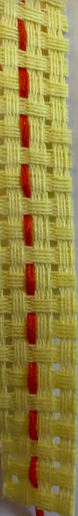

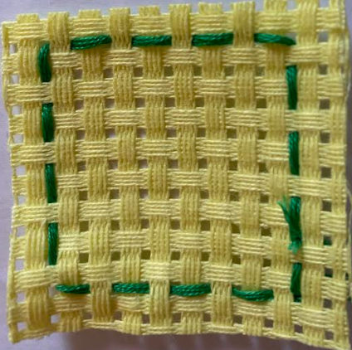

Can your child explain the process of completing a running stitch?
Can your child tell you what a seam is? (The line where two pieces of fabric are joined together with stitching)

In our final lesson, the children applied what they had learnt to create their own coaster. First, they had to create square shape around the edge of their coaster using a running stich. After that, they carefully stitched the initial of their first name in the centre.

They all did such a wonderful job and we are very proud!

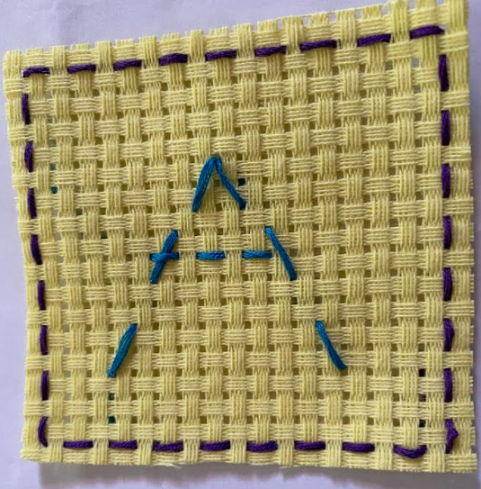

Reminders:
Class 8 PE days are Monday and Tuesday.
Class 9 PE days are Monday and Wednesday.

Attendance for KS1:
Class 8 – 96.3%
Class 9 – 92.2%

Homework
Homework will mainly be handed out on a Tuesday. On the odd occasion it may be on a different day due to timetable changes. Please return homework on a Monday. Handing it on a Monday gives you the opportunity before the weekend to ask the teacher any questions so that you are clear of how to support your child if unsure. There is a tray in each class where the homework needs to be returned. Please ask the teacher where this tray is if unsure.

Spellings
Spellings are handed out each Thursday and your child will be tested on these spellings the following Thursday. Children will receive a list of spellings to practise each week. In addition to the spellings, children will be tested on a sentence containing the words. However, the sentence will not be sent home. This is to see if they can apply the spelling currently within their writing. Can you get your child to practise applying the words by creating their very own sentences?

Reading Diaries
Children in KS1 have all been provided with a Home Reading Diary. Please fill this in daily based on your child reading a couple of pages of a book or a whole book. Please return the Reading Diary to school each day and leave it in the designated classroom tray. There are books situated in the classroom for your child to take home daily. Reading is extremely important to your child’s development so we really encourage your child to read a book or pages of a book daily. If you are unsure of your child’s reading book colour then please ask your teacher.

Thank you
Miss Rawding & Miss Payne

