

Royd Nursery Infant School

Carr Road, Deepcar

Sheffield, S36 2PR

Tel 0114 288 2594

Email [enquiries@royd.sheffield.sch.uk](mailto:enquiries@royd.sheffield.sch.uk)

[www.roydnurseryinfants.co.uk](http://www.roydnurseryinfants.co.uk)

Headteacher: Louise Jones

11 June 2024

Dear Parent/Carers,

On Tuesday 16 July 2024 Royd Nursery infant school will be having a joint summer fayre with Deepcar St John School. Arrival time is from 2.00 pm.

* All Parents/carers are to enter the School Summer Fayre via the main school gate (where the lollipop lady stands) as children will be situated on the big yard.
* **Please ensure your child has a water bottle and sun hat.**
* If parent/carers are not attending, children may bring money to School to spend at the Fayre. Please ensure this is put in an envelope with your child’s name on it. Do not send it loose, thank you.
* The playgrounds for both Royd and Deepcar St John will be open so that you can access all activities.
* The event finishes at 3.30 pm and children can leave from 3.00 pm.
* We would be very grateful for support from parent/carers by volunteering to run a stall eg penalty shoot out, hook a duck etc. Please contact Mr Sly by Friday 30 June. Thank you.
* We would be very grateful for support from parent/carers by volunteering some time after school to help tidy up.

**Weather**

* If the weather is dry entrance to the main playground will be via the main school gate (where the Lollipop Lady stands).
* If it is raining please make you way to your child’s classroom, where the enterprise stalls will be, via the school reception entrance. You will be able to take your child across to the hall at Deepcar Junior School where there will be more activities.

Fingers crossed for sunny weather and we look forward to seeing you all.

Yours sincerely,

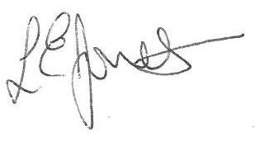

Louise Jones Sean Sly

Executive Head Acting Deputy Head





