Wednesday 19th June 2024

Dear Parents/ Carers,

As we come towards the end of the academic year I am writing to inform you about some staff changes at school.

Miss Sophie Rawding, currently a class teacher in Year 1, will be leaving Royd after teaching for 5 years. She is relocating to Manchester and has accepted a new teaching role.

Miss Kerry Bamford who teaches Year 2 and has taught at Royd for 6 years will be leaving this Summer to pursue a new career.

I would personally like to thank both these staff members for their commitment to the children, school priorities and working so hard over the past several years. They have ensured that children get the very best deal. I am sure you will join me in wishing them both the very best of wishes for the future.

We appointed two new teachers earlier this term who have already spent time in the school. Miss Ellie Aldam and Miss Stephanie Howes will both be working in Key Stage One alongside Miss Hannah Payne.

Yours sincerely,
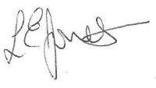
Louise Jones

