

Royd Nursery Infant School

Carr Road, Deepcar

Sheffield, S36 2PR

Tel 0114 288 2594

Email [enquiries@royd.sheffield.sch.uk](mailto:enquiries@royd.sheffield.sch.uk)

[www.roydnurseryinfants.co.uk](http://www.roydnurseryinfants.co.uk)

Headteacher: Louise Jones

11 June 2024

Dear Parents/Carers,

On Monday 15 July 2024 School is holding a Sports Day. It will take place on the yard at Royd Nursery Infants School from 9.30 am until midday.

* All children need to come to School dressed in suitable outdoor PE clothing; T shirt, jumper, jogging bottoms and or shorts (weather depending).
* All children must bring a cap, sun cream and a water bottle.
* Earrings must be removed before coming to School.

To watch the morning’s events, access will be via the main School Gate or you can go straight to the yard at 8.50 am after dropping off your child.

* **Parent/carers must arrive on time.**
* **School gates will be closed at 9.30am prompt.**
* **Nobody will be allowed entry after this time.**

The children will be out at 9.30 am. Should the weather be bad ie raining, school will attempt to reschedule for later in the week but this cannot be guaranteed.

If you would like to join us please complete the slip below and return it by Thursday 4 July 2024. Thank you.

Yours sincerely,

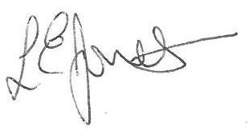

Louise Jones Sean Sly

Executive Head Acting Deputy Head

____________________________________________________________________________

**Sports Day Monday 15 July 2024**

Name of child: Class:

Yes I/we would love to join attend the sports day and understand that arrival must be by 9.30am

Signed ____________________________________________________ Parent/carer





