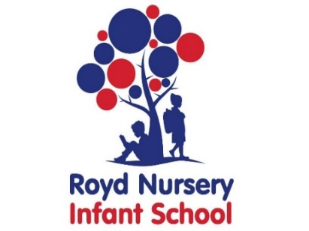

Royd Nursery Infant School

Carr Road, Deepcar

Sheffield, S36 2PR

Tel 0114 288 2594

Email [enquiries@royd.sheffield.sch.uk](mailto:enquiries@royd.sheffield.sch.uk)

[www.roydnurseryinfants.co.uk](http://www.roydnurseryinfants.co.uk)

Headteacher: Louise Jones

6 June 2024

Dear Parent/Carers

In the Foundation Stage we have enjoyed learning all about minibeasts and now we are learning about dinosaurs. To celebrate all creatures great and small we have invited Creature Ark to visit us in school on Wednesday 3 July 2024.

Mags and her team of creatures, will be working with our 2-year provision and Nursery. Children will have the opportunity to observe and hold (should they wish) a range of creatures, including a snake and a tarantula. They will be encouraged to ask questions to develop their own understanding of the different creatures, their habitats and everyday needs in order to survive. We would like for parents/carers to join us to share the experience with your child/children. Please complete and return the slip below to school to let us know you are attending

If your child does not attend their provision on this day you are welcome to bring your child and join the session. You will need to remain with your child due to ratio’s. Please complete the slip below, return by the 26 June 2024 and a member of staff will contact you with details.

It will be a normal school day as the creatures are visiting school. The contribution for this event is £2.30 per child. If you would like your child to attend, contributions and consent are by Parentpay. Please complete this by Wednesday 26 June 2024. If there are any issues please do not hesitate to contact Mr Sly. Thank you.

Yours sincerely,

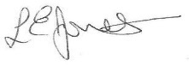

Louise Jones Sean Sly

Executive Head Acting Deputy Head

--------------------------------------------------------------------------------------------------------------------

**Creature Ark 2-Year Old Visit July 3 2024**

Name of Child : Class : E2

Yes my child attends on Wednesdays and I/We would like to join the session.

My child does not attend the 2-year old provision when the visit is due to take

place and I would like them to attend.

Signed :___________________________________________________ Parent/Carer





