This Week
This week we have continued our new topic ‘Which is the biggest dinosaur?’
We have looked at a range of information texts about dinosaurs this week in our shared read sessions. We have been identifying the names of different dinosaurs and sorting which ate meat (usually stand on 2 legs and have sharp claws and teeth) and which ate plants (stood on 4 legs and no sharp teeth or claws).
In phonics this week, the children have learnt some new sounds with their peers, where they have had to hear and say the sound and then practice writing it.
In mathematics this week, children have continued with adding the correct amount of pegs corresponding to the number given or the addition calculation on the dinosaurs to complete their ‘spikes’.
Our writing this week has been focused on tracing patterns on dinosaurs. We have carefully followed the different lines to develop our fine motor skills.

Class 5 attendance- 88.8%
REMINDER  For children starting Reception in September it is transition week next week from Wednesday-Friday.  (below is a check sheet provided to support your child at home with preparing themselves for starting school, please take a look at the bottom of the newsletter)  We have also had a number of parents informing us that their child is struggling with toilet hygiene in particular with wiping themselves. Please see the information article below with support on how to teach you children this skill.  Yellow group- Mrs Musgrave’s phonics group have learnt the sounds: v and y.  Red group- Miss Hosford’s phonics group have learnt the sounds: th and qu.  Green group- Mrs Bailey’s group have learnt the sound n. | Stars of the week  Mrs Musgrave -Eric- for modelling good sharing with his peers.  Miss Hosford-. Atticus- for settling into nursery really well.  Mrs Bailey- Henry M- making new friendships.  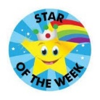
Summer term Nursery update
Donations Required!
We are requesting donations from our nursery families, to support our children with their learning through play. We require the following:
Craft: bottle tops, newspaper, material/fabric, string/wool/yarn, table cloths..
Playdough: bun cases, birthday candles/ number candles and shells.
Outside: musical instruments, scrubbing brushes, cloths, washing up bowls, spray bottles.
Clothing: boys and girls socks and tights.
Anything you could donate to nursery would be greatly appreciated. Thank you!
Homework
Homework will be given out to children on their last day of every week.
If you have lost your homework or did not receive one due to absence, please collect your own copy from the notice board in the entrance to Nursery.
Reading books
Children in Nursery are encouraged to select a book from the book box next to the peg area. Children should keep the same book for a week and return these on their last day of Nursery every week. Please ensure you change your child’s book with them in the morning. Please also note that unless the previous book is returned, a new book cannot be issued to your child until it has been returned.
Reminders
Please ensure you encourage your children to organise themselves in the morning with their cloakroom. We are working really hard on building up independence ready for children to start school in September.
If your child does require to be changed in a nappy, please ensure you have enough wipes, nappies and disposable bags packed, for the next term as Nursery do not provide these.
Please ensure your child is wearing appropriate clothing at this time of year. As you know the British weather can change at any time. Please make sure your child still brings a coat and also apply sun cream to your child before attending nursery, if possible please encourage children to do this with your guidance as they will be able to apply their own sun cream at lunchtime to be even more protected though out the day. Please make sure that your child brings a sun hat/ cap to wear on hot days. We do play outside in all weathers and are very short on spares for this to offer.
Thank you.

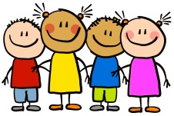

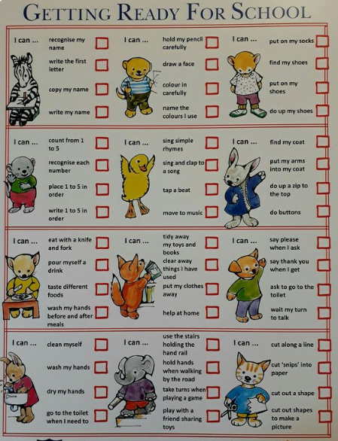

This cheeky hack will help your kid learn how to wipe their own butt
Teaching your kids how to wipe their own bum is the last hurdle in potty training, and this teacher's hack will make it a breeze.
BY KEVIN JOHN SIAZON
UPDATED APR 25, 2023

Potty training is hard. But once you get your little one to recognize when they need to go and hop on the potty in time to keep their diaper clean, you're in the clear, right? Nope. There's one last hurdle that can take a while to get over: getting them to wipe their own butt.
Before they give it a go on their own, you'll want to make sure they can do one essential movement: the Reach-Around. This is pivotal in promoting front-to-back wiping, which keeps poop out of their urethras and avoids any sort of bacterial infections in the future. It's gross to think about, we know, but it's better to build these habits sooner rather than later—both you and your kid will thank us.
You're probably wondering now how teach the Reach-Around. Do you hold their hand and do the motion while they're on the toilet? This teacher has a brilliant idea. Take a look:
Repeat method until paper is clean.

Genius. We're not sure where the video originated, but this teacher should be given all the awards for saving us the struggle... and giving us a laugh. Although we think this is a great teachable moment, we noticed the balloons are positioned higher than their actual bum would be. So before you try this at home, move them down a little. You don't want your kid to learn to just wipe the top of their bum.
Secondly, the video uses a chair with a back, which might have your child leaning back too much and relying on it to hold their weight while they wipe. Consider using a stool that lets them properly learn how to balance on the toilet and attaching the balloons below it.
One last thing you'll want to teach them is how to hold the toilet paper so that they don't get any poo on their hands. Check out the second tip in this video for another awesome hack:
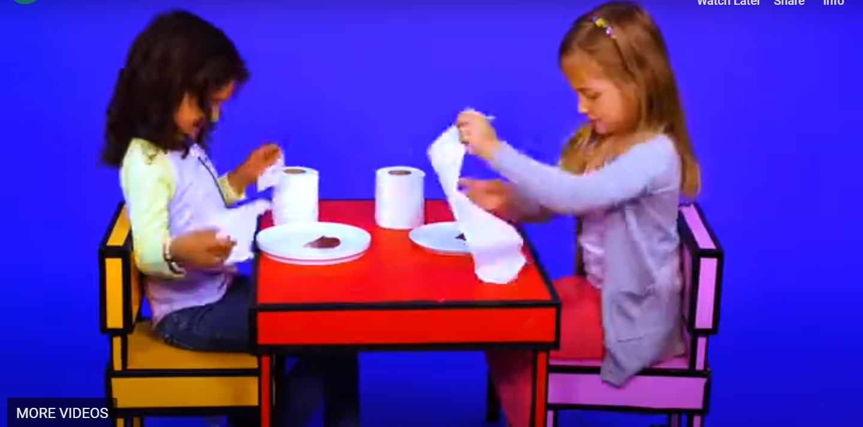
Video link: https://www.youtube.com/watch?v=4TEduQZEdzY

Ask your child to clean the chocolate spread off the plate with toilet roll without getting it on their hands.

Identify how much paper they would need for a poo or a wee.

What you'll need to give this butt-wiping lesson at home:
- A small stool or kid-friendly chair (we love these for hand-washing too!)
- Balloons
- Toilet paper

Once they've got those two down, it's all a matter of practice from there. Good luck!

