2 Year Provision Newsletter
– w/c 30/05/24
Last week

In provision we continued our topic
“Why do spiders eat flies?”
The children have enjoyed exploring this topic, making spiders, building bug hotels, going on a bug hunt! They have learned about different insects and their habitats!

This week  We are continuing our theme around our topic.  We are also looking at the seasons, as we move from spring into summer. | Book of the week  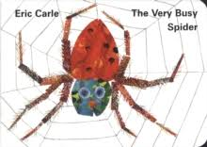  This story is linked to our theme we are running this term.  Maybe if you have this story at home you could look though the story together at bedtime.
Dates for your Diary
Friday 24th May – last day of term
Monday 3rd June – Back to school

Spare Clothes
We are running very low on spare clothes, especially boys’ clothes. If you have any spares at home your child no longer fits in, or wears and your happy to donate them please bring them to the 2 year provision.
Thank you!

Reminder
A gentle reminder about only providing water in water bottles. Thank you.

As the weather is now beginning to become a little warmer can you please ensure your child has a labelled sun hat and is wearing sun cream.
Can you also ensure they have their water bottle so they are able to stay well hydrated during the warm weather.
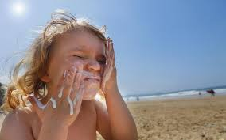

Please remember to ensure all your child’s clothing and water bottles are labelled and if you could provide spare clothes in their bag as we are very low on spare clothes.
Thank you!

