

Royd Nursery Infant School

Carr Road, Deepcar

Sheffield, S36 2PR

Tel 0114 288 2594

Email [enquiries@royd.sheffield.sch.uk](mailto:enquiries@royd.sheffield.sch.uk)

[www.roydnurseryinfants.co.uk](http://www.roydnurseryinfants.co.uk)

Headteacher: Louise Jones

24th May 2024

Dear Parent/Carers,

As part of next term’s topic 'Moon Zoom', we have invited Wonderdome Planetarium to visit and bring an exciting multimedia exploration of the solar system. The contribution for this event is £5 per child

The event will be on the afternoon of Tuesday 2nd July 2024. The activities the children will be doing will be inside a large dome that will be set up in the School Hall and will take them on a virtual tour through the solar system and beyond.

If you would like your child to take part, contributions and consent are by Parentpay. Please complete this by Tuesday 25th June 2024. If there are any issues please do not hesitate to contact Mr Sly. Thank you.

Yours sincerely,

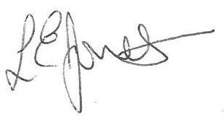

Louise Jones Sean Sly

Executive Head Acting Deputy Head





