
Weekly Newsletter
W.B. 6.5.24

Please can we ask that any reading books taken home are returned to your child’s classroom book boxes after they’ve been used.

This week:

This week in English the children have continued their story writing focus. This week we have created plans to help us write our stories. We then wrote the start and build up of our stories, ensuring we include our steps for success such as story language, past tense and punctuation.



Can your child tell you the story language they have used for the ‘start’ of their story?
Can your child tell you the two characters in their story?

As part of Maths, the children have been learning how to solve missing number calculations on an empty number line this week. They had to remember to start with the first number, count on (addition) or back (subtraction) to the answer and then count their counts (to find the missing number)!

Can your child complete the following calculations using an empty number line?

8 + ____ = 16

12 - ____ = 7

Our topic for this half term is ‘Enchanted Woodland’. As part of topic lessons, the children have continued their science learning. We have learnt about the parts of a plant and labelled them.

Year 1 also enjoyed a trip to The Glen this week to learn about different plants and trees. Children were given a checklist with different names of flowers and trees. They had to find these plants and describe their features before checking them off.

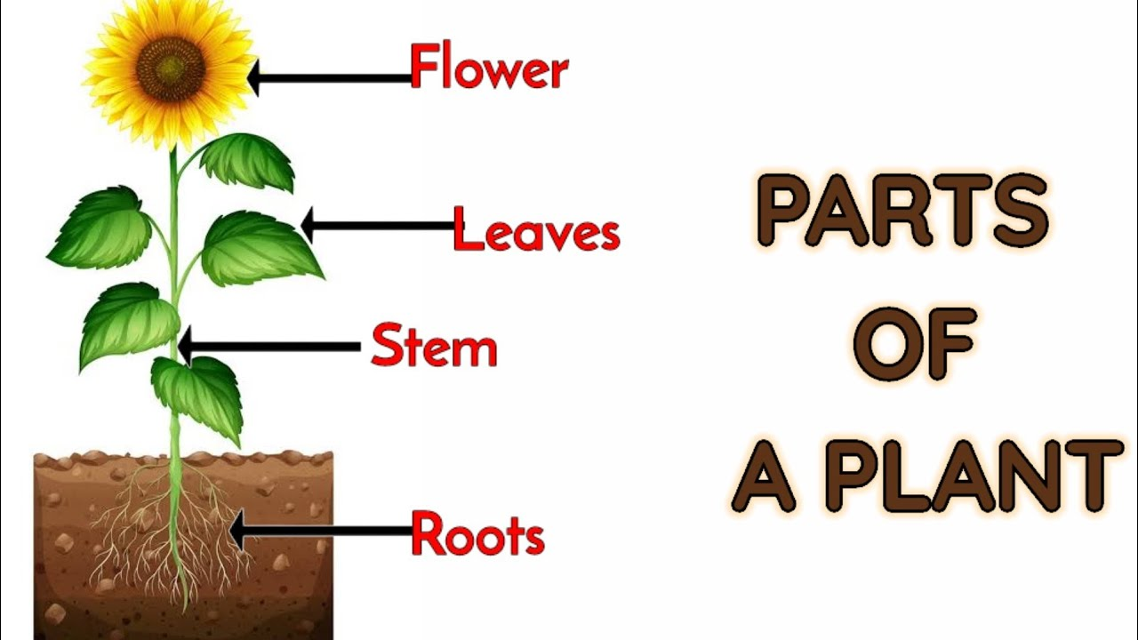

Can your child name the different parts of a plant?

As part of Geography, children in Year 1 have researched about the seasons; Autumn and Winter to prepare them for writing their information text about the four seasons.

Can your child name the four seasons?



Reminders:
Class 8 PE days are Monday and Tuesday.
Class 9 PE days are Monday and Wednesday.

Attendance for KS1:
Class 8 – 98.1%
Class 9 – 90.7%

Homework
Homework will mainly be handed out on a Wednesday. On the odd occasion it may be on a different day due to timetable changes. Please return homework on a Monday. Handing it on a Monday gives you the opportunity before the weekend to ask the teacher any questions so that you are clear of how to support your child if unsure. There is a tray in each class where the homework needs to be returned. Please ask the teacher where this tray is if unsure.

Spellings
Spellings are handed out each Thursday and your child will be tested on these spellings the following Thursday. Children will receive a list of spellings to practise each week. In addition to the spellings, children will be tested on a sentence containing the words. However, the sentence will not be sent home. This is to see if they can apply the spelling currently within their writing. Can you get your child to practise applying the words by creating their very own sentences?

Reading Diaries
Children in KS1 have all been provided with a Home Reading Diary. Please fill this in daily based on your child reading a couple of pages of a book or a whole book. Please return the Reading Diary to school each day and leave it in the designated classroom tray. There are books situated in the classroom for your child to take home daily. Reading is extremely important to your child’s development so we really encourage your child to read a book or pages of a book daily. If you are unsure of your child’s reading book colour then please ask your teacher.

Thank you
Miss Rawding & Miss Payne

