

Royd Nursery Infant School

Carr Road, Deepcar

Sheffield, S36 2PR

Tel 0114 288 2594

Email [enquiries@royd.sheffield.sch.uk](mailto:enquiries@royd.sheffield.sch.uk)

[www.roydnurseryinfants.co.uk](http://www.roydnurseryinfants.co.uk)

Headteacher: Louise Jones

16 May 2024

Dear Parents/Carers

For children in FS2, Y1 and Y2 we are running several extra curricular activities during the Summer 2 half term.

The popular club of Ball games returns on a Monday plus a new club to school is Mini First Aid. This will be on Fridays

For your child to attend, you will need to log on to Parentpay then select and pay for the club/s you wish your child to attend. This will be on a first come first served basis and the places become available later this evening.

Yours sincerely,

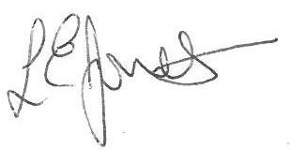

Louise Jones Sean Sly

Executive Head Acting Deputy Head

-------------------------------------------------------------------------------------------------------------------  
**Extra Curricular Activities Summer 2 2024**

**Monday**

Ball Games FS2/Y1/Y2 3.20pm – 4.20pm 3 Jun – 15 Jul £28

**Tuesday**

Dance FS2/Y1/Y2 3.20pm – 4.20pm 4 Jun – 16 Jul £28

**Wednesday**

Football Y1//Y2 3.30pm – 4.30pm 5 Jun – 10 Jul £24

**Thursday**

Choir Y1/Y2 3.20pm – 4.00 pm 6 Jun – 11 Jul £1

**Friday**

Mini First Aid FS2/Y1/Y2 3.20pm – 4.20 pm 7 Jun – 19 Jul £28





