

Royd Nursery Infant School

Carr Road, Deepcar

Sheffield, S36 2PR

Tel 0114 288 2594

Email [enquiries@royd.sheffield.sch.uk](mailto:enquiries@royd.sheffield.sch.uk)

[www.roydnurseryinfants.co.uk](http://www.roydnurseryinfants.co.uk)

Headteacher: Louise Jones

24 May 2024

Dear Parents and Carers,

As you are aware the school photographer will be here on Wednesday 5 June 2024 to take the yearly class photograph.

If your child attends the 2 year provision and does not attend on a Wednesday and you would like your child to be on the class photograph the sessions will at;

* 9.10 am – please bring your child to the main school reception for 9.05 am
* and 1 pm - please bring your child to the main school reception for 12.55 pm

If your child attends the Nursery provision and does not attend on a Wednesday and you would like your child to be on the class photograph the sessions will at;

* 9.25 am – please bring your child to the main school reception for 9.20 am
* and 1.15 pm - please bring your child to the main school reception for 1.10 pm

You will receive a proof from the photographer with details of how to place an order. The orders are not be placed via School. Thank you.

Yours sincerely,

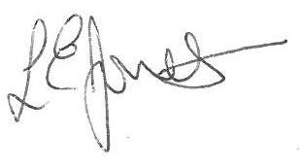

Louise Jones Sean Sly

Executive Head Acting Deputy Head





